H2020: SmartConnect: Large Scale Personalised and Integrated Care Pilots

*Innovation in Integrated Care for Cancer Patients: Digital Solution for Palliative Care, Psychosocial & Symptom Management*

**Summary**

|  |  |
| --- | --- |
| **Project Name:** | SMARTCONNECT |
| **Call** | SC1-DTH-11-2019 |
| **Duration:** | 42 months |
| **Type of Action** | Innovation Action |
| **Project Coordinator:** | ATC, Greece |
| **Technical Coordinator** | ENG, Italy |
| **Clinical Council Lead:** | ANT, Italy |
| **Platform Lead:** | CAPS, Ireland |
| **Academic Coordinator:** | TUE/JADS, Netherlands |
| **Exploitation Lead:** | TBD |
| **Commercial Lead** | TBD |
| **Private Cloud Lead** | Webair-Netherlands |

**Consortium Participants**

|  |  |  |  |
| --- | --- | --- | --- |
| **Participant No:** | **Participant** | **Short name** | **Country** |
| 1 | ATC (Coordinator) | ATC | Greece |
| 2 | JADS/TU/Eindhoven | TUE/JADS | Netherlands |
| 3 | University of Crete Hospital | UOC | Greece |
| 4 | CapsicoHealthCare, Ltd | CAPS | Ireland |
| 5 | Tampere University of Technology | TAU | Finland |
| 6 | Movendos, Ltd | MOV | Finland |
| 7 | Erasmus Medical Center | EMC | Netherlands |
| 8 | Engineering Ingegneria Informatica S.P.A | ENG | Italy |
| 9 | AECC** (under review) | AECC | Spain |
| 10 | Oncoavanze – Cancer Clinic | ONA | Spain |
| 11 | ANT-Eubiosia – Cancer Care | ANT | Italy |
| 12 | Irish Care Groups | APC | Ireland |
| 13 | Salumedia | SAL | Spain |
| 14 | SAS Hospital | SAS | Spain |

Contents

1 Excellence 4

1.1 Objectives 4

1.2 Relation to work programme 5

1.2.1 Innovation 5

1.2.2 Digital solution and efficiency 6

1.2.3 Professionals, data sharing and security 7

1.2.4 Outcomes and Quality of Life 9

1.2.5 Scalability and Reliability of Digital Solution 10

1.3 Concept and approach 10

1.3.1 Approach 11

1.3.2 Connected actionable patient engagement record (CAPER) 12

1.3.3 Minimum Data Set (MDS for CAPER) 12

1.3.4 Multi-Site Pilot Summary 14

1.3.5 Pilot characteristics 15

1.3.6 Pilot user enrollment 16

1.4 Ambition 16

1.4.1 Scale across Europe 16

1.4.2 Patient engagement record for millions 17

1.4.3 Patient empowerment 17

2 Impact 18

2.1 Expected Impact 19

2.2 Measures to maximise impact 20

2.2.1 Dissemination and Exploitation 21

2.2.2 Communication Activities 21

3 Implementation 22

3.1 Work Packages 28

3.1.1 Work Package Summary 28

3.1.2 Work Package Effort 30

3.1.3 Work Package Details 31

3.2 Management Structure 60

3.3 Consortium as a whole 60

3.4 Resources to be committed 62

4 Bibliography 63

# Excellence

## Objectives

Europe comprises only one eighth of the total world population but has around one quarter of the global total of cancer cases with some 3.7 million new patients per year. Cancer represents the second most important cause of death and morbidity in Europe, and a vast majority of the Cancer patients are 65 years of age and above [1][2]. During 1995, 2.6 million people were diagnosed with cancer, and in 2018 about 3.8 million were diagnosed. ***Cancer is set to become the biggest cause of death and disability in Europe in the coming years.*** Elderly patients diagnosed with Cancer conditions are in need for better symptom management during treatment. Over 30% of Cancer patients are candidates for early Palliative care requiring pain management, social, psychosocial and nutritional support. Most elderly Cancer patients have at least 2 chronic conditions (e.g. Hypertension or diabetes or heart failure or mental health), and the impact on daily life can be debilitating, and any unplanned visit to the emergency room or hospital can add to the burden on care and costs.

SmartConnect project aims to enable a ***secure digital platform and patient engagement solution*** for ***five pilot sites*** across Europe, and plans to integrate 18,000 users (Cancer Patients and Professionals) for personalised care delivery, while improving adoption by professionals in certain European regions by 50%. The Pilots aim to enroll patients (Palliative and Curative stages) with complex uncontrolled symptoms (e.g. pain) and psychosocial needs (e.g. nutrition, home support, spiritual) and social support (e.g. domestic support) that require care from a multidisciplinary group of professionals during and after Cancer treatment. In addition, SmartConnect aims to empower patients with Smart phone applications (apps) to enable scheduling of preferred services (e.g. local pharmacist, therapist, GP), self-management and “anytime” communication (video & text) with care professionals.

Across Europe patient engagement and self-management tools combined with integrating a large number of professionals are critical **gaps** that need to be addressed for timely care and quality of life improvement for Cancer Patients. SmartConnect seeks to bring a **first-of-a-kind** flexible digital platform for a large number of users across multiple Pilot sites in Europe for care delivery. SmartConnect aims to demonstrate the value of the platform for personalizing care and patient engagement through smart phone apps (video, text & assessments). SmartConnect seeks to generate a ***connected actionable longitudinal patient engagement record (CAPER)***, currently missing from traditional hospital medical records, for personalizing care.

***The main objectives of the SmartConnect Proposal are as follows:***

1. Enable multi-site large scale pilots with tens of thousands of users (Patients and Professionals) across Europe to demonstrate personalised and scalable digital solutions for managing care in a multi-disciplinary environment for Cancer Patients (in need of Palliative services)
2. Deploy secure, accurate and reliable data sharing models (and a minimum data set) across the care team professionals and patients, while improving the adoption and productivity of professionals
3. Enable smart-phone based mobile applications to empower patients (through surveys, questionnaires for pain assessment, video chats, digital wound assessment, SF-36, SF-12, and PHQ9) on Quality of life and specific disease-oriented assessments.
4. Bring flexible and simple-to-use digital platform to enable higher percentage of adoption by professionals involved in care delivery with the ability to access, analyse and share pertinent patient record information
5. Measure and report on Cost, outcomes, improvements and financial viability
6. Demonstrate GDPR driven privacy enabled workflows on accessing social data and information in IT supported environment for personalized care (EU data protection regulation).
7. Enable technology, clinical and academic best practices and leverage good practices from existing networks such as B3 (an EU funded integrated care good practices network)

## Relation to work programme

The EU H2020 call objective: large-scale pilots for deployment of trusted and personalised digital solutions dealing with Integrated Care, with a view to supporting and extending healthy and independent living for older individuals who are facing permanently or temporarily reduced functionality and capabilities. This in turn is expected to contribute to a patient-centered and truly individualized strategy. The call aims for scalable care management, patient self-management & empowerment.

### Innovation

***What new value is SmartConnect offering?*** SmartConnect brings a next generation digital solution consisting of best in breed technologies and clinical processes for engaging patients (in need of Palliative care, psychosocial and symptom management) and integrating professionals (e.g. GPs, pharmacists, therapists & psychologists) at multiple Pilot sites (managed by Cancer Centers) in Europe. SmartConnect seeks to ***drive innovation*** in the following areas:

1. Scalable integrated digital platform for professionals and best-in-class patient-engagement tools for patients across multiple Pilot sites in Europe. Connecting tens of thousands of users efficiently has not been done well in the past. Projects such as ActiveAge[1], MasterMind[2], SmartCare[3], and several B3 Integrated projects[4] offer IoT[5] or assisted living or smart living or change management methods to integrate large communities and social care, but ***no operational digital platform and patient engagement apps*** at-scale for patients and professionals. MasterMind (EU project) integrates 1000 patients to demonstrate concepts. SmartCare added 10,000 users (including 2000 professionals). CASA[6] (EU project) is focused on social care policy, assisted living models, and knowledge sharing. ACT[7] drives best practices for Telehealth and Care coordination. Interreg[8] is large change management project for regional policy and development.
2. A unique model to empower and engage patients with **smart phone apps** for symptom feedback, scheduling visits, accessing services, short duration video visits, wound-care images and improved communication. The digital platform will capture a longitudinal, **connected, actionable patient engagement record (CAPER)** over multiple months and provide new insight to care teams & professionals for personalizing care. An illustration of the Patient engagement record is shown in Figure 2.
3. A value-added minimum data set (**MDS**) for a patient engagement record (shown in Figure 2) that includes demographics, video, audio and text communication summaries, annotations, symptom summaries, services schedules and unit of work capture per patient by various service providers.
4. An advanced analytical and reporting system to allow for deep analyses of patient engagement and patient reported multi-modal data (video, images, text) for outcomes analyses. The analyses will be conducted using advanced machine learning models on CAPERs to analyse outcomes and costs per unit work by professionals, models for future scalability, and reduction in negative outcomes (e.g. hospital visits).
5. Flexible business process management tools combined with cloud computing frameworks to register, invite, connect, secure and integrate several thousands of users (Patients and Professionals) across the various Pilot sites and regions. The integration will ensure privacy and security of the patient data.

In the following tables we outline for each of the H2020 call objectives our response on solving the critical challenges and reaching the appropriate success measures.

### Digital solution and efficiency

|  |  |
| --- | --- |
| H2020 Call scope & objectives | SMARTCONNECT Project scope |
| *“To enable large-scale pilots for deployment of personalised and replicable digital solutions dealing with Integrated Care in a multidisciplinary environment”* | SmartConnect Digital solution and platform aims to integrate over several thousand patients and professionals from multiple disciplines across five Pilot sites in Europe (that includes 5 Cancer care hospitals, home care and care groups).  SmartConnect aims to:   * enroll over 16,000+ patients over 2.5 years across the Pilot sites * enroll over 2000+ professionals over 2.5 years across the sites * demonstrate the seamless integration of all users at Pilot sites * drive better patient engagement & integration with professionals * improve patient experience and self-management * involve more social care professionals to help patients * develop sustainability models to integrate hundreds of thousands of patients and professionals beyond the SmartConnect project through partnerships with public health providers, policy markets, patient advocacy groups and cancer registries   SmartConnect brings best in class integrated care good practices and healthcare industry driven technologies and processes to enable 5 large scale Pilots across countries in Europe.  SmartConnect’s partners have tremendous experience in integrating and scaling over hundreds of thousands of users over multiple years, and hundreds of millions of patient records. Partners include ranked healthcare companies, patient engagement providers, reputed hospitals, university cancer centers, social care groups, NGOs, patient advocacy groups, cancer registries and regional public policy members and Oncology specialists. |
| *“Ensuring Efficiency gains in terms of resource allocation and coordination of care”* | SmartConnect’s digital platform will enable care coordination though information sharing and workflows amongst the professionals involved in delivering care to the patients (at different settings). SmartConnect aims to improve the efficiency in care delivery based on timely and personalised information sharing with professionals (e.g. Pharmacists notified on pain medication and reconciliation for patients in need).   * Improvements in time-spent per patient per professional * Reducing time lost due to technolgy application * Reducing unplanned visits to the hospitals * Reducing unplanned visits to the emergency room * Better coordination of care across professionals through secure data sharing, capture and role-based access. |
| *“Flexibility and replicability of service delivery patterns to combine personalization and large-scale adoption of services with patient and citizen feedback”* | SmartConnect’s vision is one digital platform for multiple Pilot sites supporting professionals and patients.   * Creation of a unique MDS (minimum data set) model to capture a wide range of patient conditions and patient engagement data * Flexible processes to add any certified user to the digital platform * Ability for the patients and families (citizens) to use the smart phone apps to schedule services, communicate with care teams, and be connected to the familiies and care givers. * Flexible methods to include a variety of disease specific and quality of life questionnaires * The assessments can be widely deployed across multiple sites, and in the future across hundreds of sites in Europe * Data extraction (ETL) methods to pull demographic and treatment profiles from electronic medical records of the hospitals and clinics * Flexibility to identify the patient cohorts that need Palliative care and support * Flexibility to add a variety of professionals (e.g. pharmacists, therapists, GPs, clinical staff, etc) |

### Professionals, data sharing and security

|  |  |
| --- | --- |
| H2020 Call scope & objectives | SMARTCONNECT Project scope |
| *“Ensuring accuracy, reliability and security of data sharing at each step of data stream to increase recruitment of professionals and patients, whilst improving professionals' working conditions”* | SmartConnect aims to deploy a commercial grade, proven (market ready) digital platform and patient engagement tools to integrate and personalise care for Cancer patients in need of symptom management, palliative care and psychosocial services.  SmartConnect will ensure that the minimum data set (MDS) will be adequately deployed to allow professionals to review the longitudinal patient record (CAPER) and make timely decisions for care. With a clear patient engagement record combined with the patient treatment summary (from the hospital based electronic medical record) the foundations are set for personalising care to the right patients.  SmartConnect will measure and improve the recruitment of professionals and adoption by them for care delivery   * Current adoption by professionals of digital solutions is less than 20% across Europe, and in some cases less than 1% within a region, and over 50% in progressive countries. Professionals include pharmacists, social workers, GPs, home health aides, nutritionists, psychologists and therapists. * Our aim is to improve the adoption ratio of professionals to be between **10% to 50% within a hospital network or a region** * Our aim is to integrate nearly all professionals (> 90%) where paper medical records are being used for Cancer care decision-making, and daily efficiencies can be impacted for patient care. * SmartConnect aims to demonstrate that nearly 100% of the certified professionals can be integrated, and for these professionals the aim is improve efficiencies through a minimum Data set, and timely care delivery. * SmartConnect will bring forward data quality and security methods to ensure that sharing of information between clinical groups and professionals is done in a secure and timely manner. Specialised ETL (Extract, transform and load) tools will be leveraged in the Pilots to more securely data from medical records and applications into the common digital platform. * We also aim to leverage existing EU supported B3 Integrated network practices to involve public health, social care and communities. This will allow for further integration of professionals to support patient care |
| *“Users trust with regard to health and social data and information in IT supported environment, in line with existing EU data protection regulation (and if required with EU reflection on platforms)”* | SmartConnect brings tremendous experience and technology related to GDPR and will deploy the Digital solution and platform on a GDPR enabled private cloud in Europe, and ensure existing EU data protection regulations are met. SmartConnect with hire a Privacy expert (DPO) to be a part of the project. The privacy expert will ensure the following:   * Engage Privacy officers at each site (e.g. hospitals, clinics) * Review GDPR policies for the Pilot sites * Review GDPR policies for the Digital platform * Review GDPR policies for patient engagement tools * Certify the Digital platform * Certify the processes to protect all data   Several metrics to privacy will be supported to ensure that no patient data is ever left unencrypted. These metrics include system and application level encryption and secure communication channels   * Encryption levels on the Smart phone * Encryption levels on the Digital Platform * Certifications on the Digital platform * Patient privacy rules being followed |

### Outcomes and Quality of Life

|  |  |
| --- | --- |
| H2020 Call scope & objectives | SMARTCONNECT Project scope |
| *“Designing outcome-based reliable and sustainable business models”* | SmartConnect aims to leverage proven outcomes measurements on care processes, clinical outcomes, utilization measures and overall business models for enabling lower cost of care per patient per year.   * A 10%-20% reduction in emergency visits reduces the per patient per year costs (per episode costs) providing a sustainable model for managing care. We expect the per patient hospital costs to drop per day by 10% for the patients enrolled in the SmartConnect digital platform. * The reduction in visits can be achieved through better patient communication with providers on uncontrolled symptoms, complications and toxicities, and we plan to demonstrate that through the Multi-site Pilots * Reduce hospitalizations by 10% across the Pilot sites through continuous care with the patients (who will be connected to the digital platform and care givers through smart phones) * Reduce length of stay of Cancer patient admitted to the hospitals. Currently an average bed cost per day is over 350 Euros per day. A single-day admission can add to the costs and reduces the effectiveness of the Care management team. |
| *“Quality of life should be measured on the basis of commonly used questionnaires (like SF36) but also if required on the basis of specific disease-oriented measurement tools”* | SmartConnect’s patient engagement tools are world-class technologies proven in Europe to enable patients to do secure video chats, set up appointments, schedule visits, take pictures in a secure way for digital wound assessment (cancer patients with surgery). SmartConnect will measure several QoL measures based on assessments such as SF36, SF-12, PAL-C[9], PHQ9, etc.):   * Ambulation index (e.g. difficulty in walking) * Falls risk (likelihood of falls) * Difficulty bathing (basic functions) * Difficulty eating and resting * Pain level on a daily basis * Pain medication side-effects * Managing daily anxiety during the Palliative and Curative stages |
| *“Measurement of cost-efficiency should be measured on the basis of work time information dedicated to each patient”* | SmartConnect aims to analyze workflows and clinical processes through the digital platform to measure the number of work units (per professional) spent on each of the patients in the Pilot sites.   * Time units spent per professional per patient * Time units spent per patient at home * Time units spent by professionals per patient in clinical settings * Time units spent by therapists at patient homes * Time units spent by therapists in professional settings * Time units spent by professionals offering care digitally * Time units spent by professionals in person |

### Scalability and Reliability of Digital Solution

|  |  |
| --- | --- |
| H2020 Call scope & objectives | SMARTCONNECT Project scope |
| *“Harmonization, certification, approval labelling or reliable identification of adequate solutions for integrated care”* | SmartConnect project aims to bring reliable and certified digital solutions developed by various partners and others in the Industry for secure integrated platform.   * SmartConnect’s partners are experienced solutions providers in Cancer care. * Partners include top Healthcare companies, Enterprises, Cancer Hospitals and Clinics with experience in integrating care with professionals and at patient homes. * SmartConnect will also perform certification of the various technology applications and the overall digital platform * SmartConnect will also leverage “Best in Class” open source tools for privacy and security |
| *“Robust and reliable and replicable business models for IT supported solutions in a truly personalized and multi-disciplinary environment”* | SmartConnect will enable measurement of costs per user for the integrated care from the time the patients are enrolled in the care services programs. The project will measure   * The business case is to show that the per patient costs of care during and after treatment has dropped between 10% to 20% and outcomes have improved by 30%. Such a model will increase the available funds per hospital or region to support a digital platform for better patient engagement and integration of professionals. * Per patient costs for managing care at home (using IT and Mobile app enabled) versus per patient costs for managing care at the hospitals. * Savings that can compensate for supporting the digital platform |

## Concept and approach

***Integrating and personalizing care****:* Our SmartConnect proposal aims to establish a “Secure Digital Platform” for multiple Pilot sites across Europe to demonstrate integrated professional networks within a community, and to enable easy-to-use Smart phone-based tools such as video chat, questionnaires (e.g. pain scale, activities of daily living, connectivity, access, etc.) and appointment scheduling for patients (and families) to communicate back with the professionals. Our vision is that a single digital platform will help personalise care while reducing unit costs of care and unnecessary hospital visits. The challenge is to ensure that patients and patient-families are able to adopt the smart-phone apps and communicate acute symptom information and assessments (PROMs) back to the clinicians or GPs instead of making a trip to the Emergency rooms or Hospitals. In addition to PROMs, any communication (e.g. video, audio or text) from the patient to the clinicians or professionals will help capture a minimum data set (MDS) for review. We present a ***7-step approach in the following section*** for implementation, deployment, launch and operation of the multi-site pilots.

### Approach

Our **SmartConnect** proposal addresses the critical needs (e.g. set by the EU on Integrated care) of vertically[10] and horizontally[11] integrating professionals across the public health, community and social services to enable sustainable care models. Our approach is to systematically bring tens of thousands of users (e.g. patients, professionals and policy makers) across 5 Pilots sites in Europe to improve outcomes and engagement of Cancer patients in Palliative and curative stages of their Cancer. The 7-step process is illustrated in Figure 1 below.

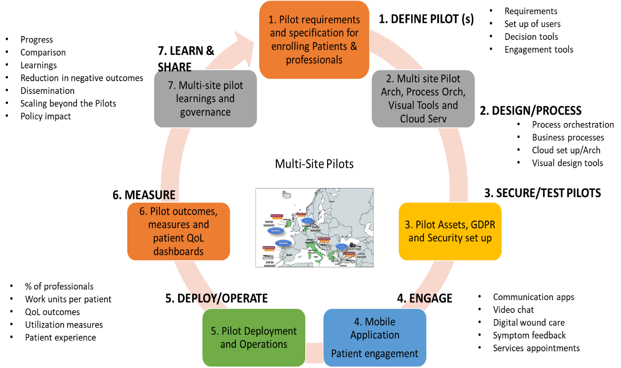

Figure 1: Multi-Site Pilot Approach to Design, Security, Operations and Outcomes

* ***Step 1 (Define):*** SmartConnect’s Pilot sites document the requirements in integrating professionals and patients onto one digital platform, and the expected patient engagement record and outcomes. Each Pilot site is unique in that they deliver Palliative care in a hospital or private clinic or home health.
* ***Step 2 (Design):*** SmartConnect’s technology partners along with clinical partners will design, document and orchestrate business/administrative processes to enroll patients and professionals to the digital platform.
* ***Step 3 (Secure):*** Each Pilot site will follow the GDPR guidelines and enable secure ways to register and scale across users (Patients and Professionals)
* ***Step 4 (Engage):*** Patient engagement tools will be tested and education material developed to enroll over 16000 cancer patients across Europe once the Pilots start operating.
* ***Step 5 (Operate):*** SmartConnect plans to steadily integrate over 18,000 users across 5 Pilot sites in multiple settings (e.g. hospitals, clinics, community, GPs, etc.) over a 2 ½ year period (30 months). Each patient has to be reviewed by the clinicians prior to enrollment to the patient engagement apps, and a minimum data set longitudinal patient engagement record (CAPER) will be made available for use by professionals.
* ***Step 6 (Measure):*** The outcomes will be measured on a daily basis on the digital platform. SmartConnect will measure Pilot performance, adoption rate by professionals and quality of life outcomes
* ***Step 7 (Learn/Share):*** Several patient advocacy and public health groups involved in the Pilots will look to partner with the local clinical settings organize workshops with professionals and regional policy specialists for future scalability and sustainability.

### Connected actionable patient engagement record (CAPER)

SmartConnect’s vision is to generate new longitudinal data sets from the patient engagement applications combined with the demographic and treatment information from the traditional electronic medical record systems.

* SmartConnect aims to build a unique longitudinal patient engagement record (multi-modal) that captures patient interactions, preferences, needs, and communication
* SmartConnect plans to bring in multi-modal data (video, audio, text), PROMS and patient feedback information into a patient engagement record for analyses and inclusion in the electronic medical records for personalization and care.
* SmartConnect plans to integrate and demonstrate the longitudinal record for all settings (e.g. hospitals, clinics, community, GPs, Pharmacists), and expand that to tens of thousands of professionals who can analyse and review the visible parts of the engagement record for timely care to the patients.

### Minimum Data Set (MDS for CAPER)

A critical part of our approach, and the innovation is in the Digital platform to capture patient engagement specific minimum data sets and creating a longitudinal record along with discharge summary of the patient from the hospital or the clinic. The longitudinal patient engagement record (PERL) shown in Figure below will enable clinicians, care teams, professionals and families to obtain new data that was not available to them for personalizing care. The care teams and families can examine the patient’s health status whenever the patient is able to share their pain levels, wound-status, uncontrollable symptoms and other information with them.

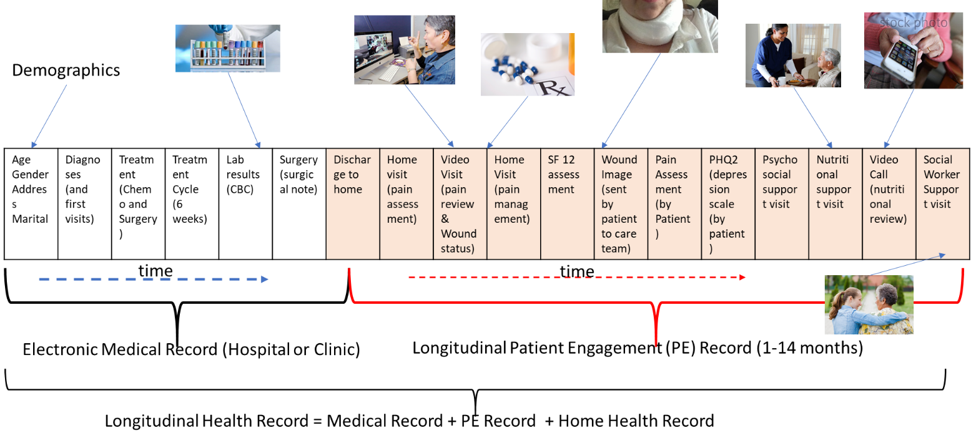

Figure 2:Minimum Data Set for a Longitudinal Patient Engagement Record (CAPER)

The MDS model considers the supply chain of professionals involved in caring for the patients, and the corresponding data collection being done for every visit. Each physical visit to the Patient’s home or a video visit (consultation) or text interaction is captured into the longitudinal patient engagement record, and provided to the care teams for review, analyses and further care related support and interventions. In Work package 5 we describe the details of the MDS record with the appropriate attributes and corresponding information per attribute. Every visit and patient interaction (through smart phones) are captured in the longitudinal patient engagement record.

**Patient population for the Pilots**

With ***value-based care*** initiatives in the horizon in Europe there is a need for technology and clinical processes for better symptom management in the Curative stage for patients, and Palliative care services for managing quality of life, nutritional issues and pain management. Figure below illustrates the various stages from Cancer diagnoses to treatment, and in the red block are the areas of interest in identifying patient populations for care improvement.

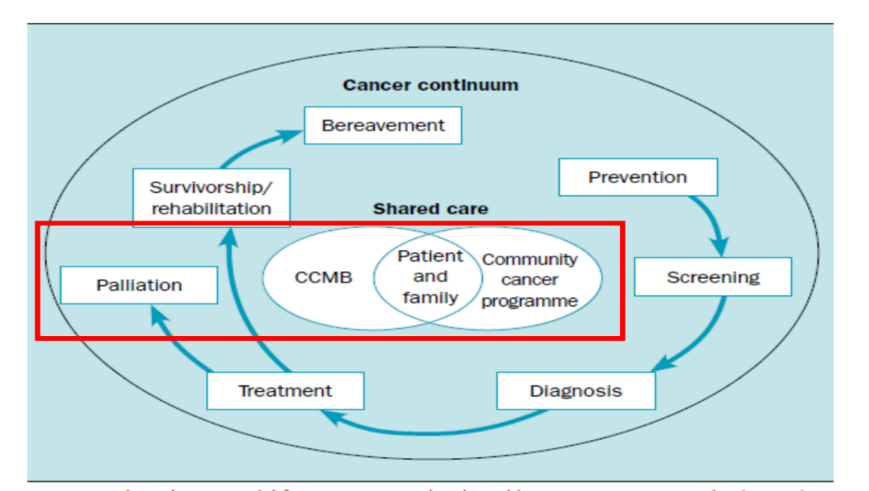

Figure 3: Care Management Services for Curative and Palliative Stages

In the following subsections we summarise the Pilot regions, characteristics, the size, the professional network, the overall KPIs and measures for success.

### Multi-Site Pilot Summary

|  |  |
| --- | --- |
| **Project: SmartConnect** | A scalable, secure Digital Platform for Integrated and Personalised Care for Cancer Patients across Europe, connecting Patients through Smart Phones and Professionals over one platform |
| Pilot planning, setup, test, education and training | SmartConnect project will perform the planning, set up, test and training, including enhancing workflows and GDPR |
| Pilot Duration | 30 months for live operations to enroll and care for patients |
| Pilot Summary |  |
| Region size | Over 150 Million population size across the 5 countries |
| ***Target number of Patients*** | 16000 over the 30 months (to be enrolled) |
| ***Longitudinal patient engagement record*** | Visits, video consultation, text communication, scheduling of services, video calls and other support related visits |
| Scalability Model | GP network, regional policy, social care, community health, home health, social workers, hospitals, clinics and psychologists |
| Disease areas | Cancer Care – All Cancer areas (e.g. lung, colon, breast, prostrate, head and neck, and more) |
| Disease stages | Stages 2, 3 and 4: Palliative and Curative (ages 60 and above) |
| Areas of Care | Palliative, Symptom management and Psychosocial services |
| ***Professionals and their service*** | 2000 across multiple regions: public health, public hospitals, community centers, home health agencies, GPs, therapists, patient advocacy groups, therapists, pharmacists, and community health |
| *Pilot Sites* |  |
| Pilot site A: | University of Crete Hospital – Medical Oncology |
| Pilot site B: | Erasmus Medical Center (Academic Hospital) |
| Pilot site C: | ANT – Home care group for Palliative care (Cancer care) |
| Pilot site D: | Oncoavanze, private Cancer clinic |
| Pilot site E: | Virgen del Rocio University Hospital, Andalucía, Spain |

### Pilot characteristics

***Pilot Size and Integrated Networks***

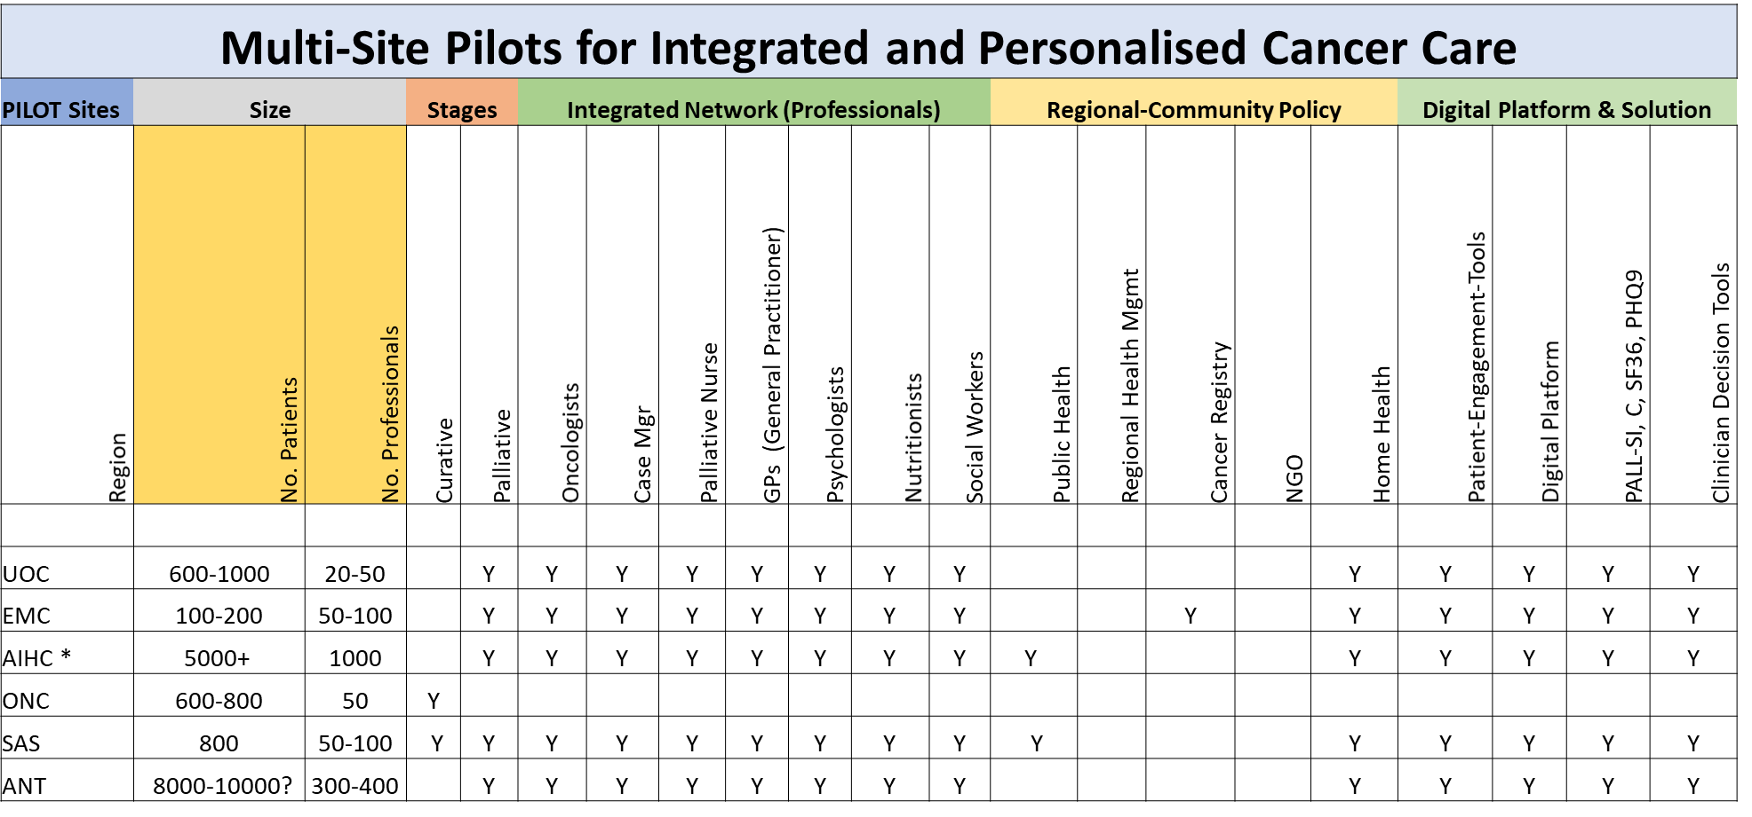

Figure 4:Pilot Summaries

In Figure 4 above we describe the Pilot site characteristics, including each Pilot’s network of professionals, size, the expected integration to regional and community, and the overall Digital platform needs. For each pilot we track the social care integration and the digital platform needs. Pilot sites (EMC, ONC, ANT and SAS) will allow for integration of the specific patient records from the electronic medical records (EMRs) onto the common digital platform to track outcomes, unit costs, quality of life and other measures. Pilot site UOC currently operates on paper records, and are moving to an electronic version in the coming months. Pilot sites such as Erasmus-MC (EMC) in the Netherlands have been offering Palliative care and populating the electronic medical record with rich information, however their patient engagement solutions are lacking, and are eagerly looking to leverage the longitudinal patient engagement record for improving care, experience and satisfaction.

**Pilots KPIs and Quality Measures**

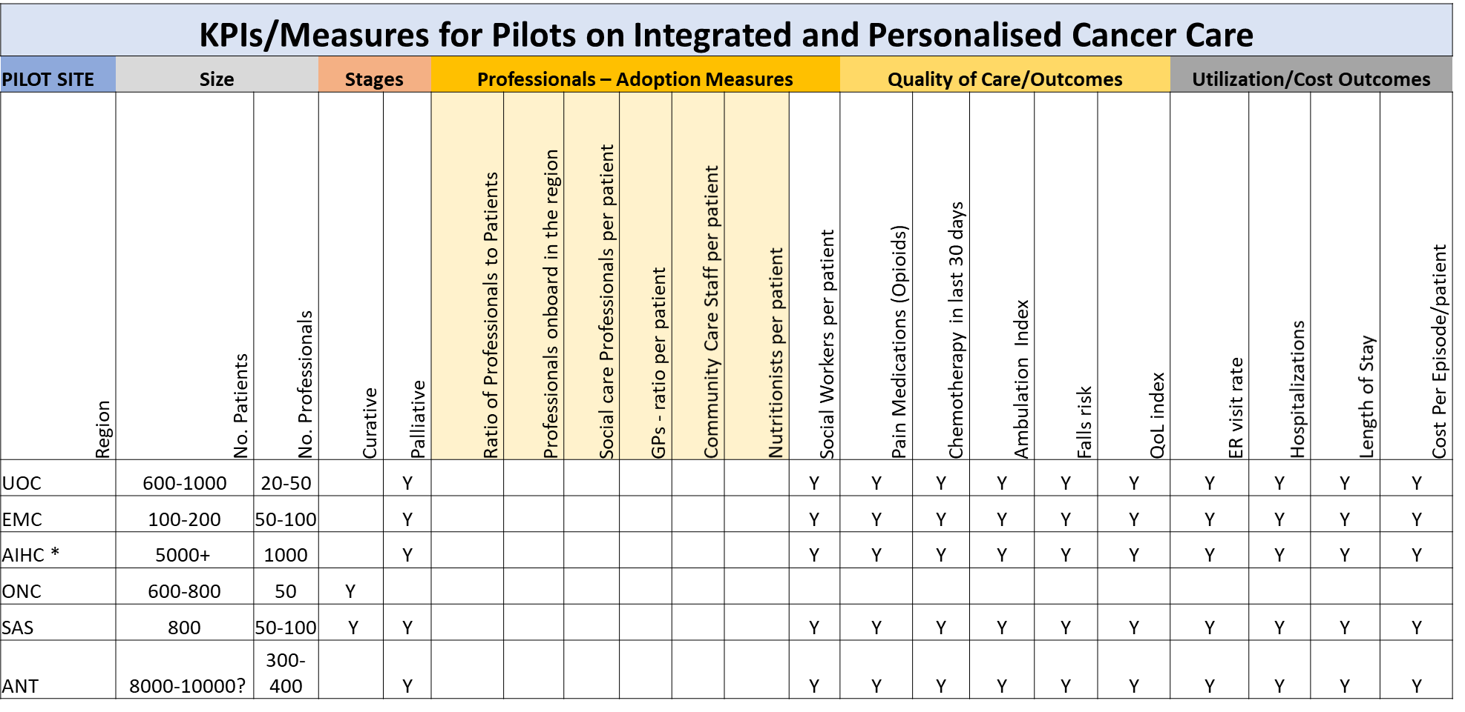

Figure 5: KPIs on Professionals and Patient Quality Measures

In the Figure 5 we describe the Pilot KPIs, patient QoL measures, and overall performance measures, including the performance of the professionals. For each pilot we track the same KPIs (with some minor variation), the extent of professional and social care integration. All Pilot sites (EMC, ONC, ANT, SAS and UOC) have established measures based on their on-going Palliative and Symptom management care protocols. The Pilot sites will allow for integration of the specific measures onto the common digital platform to track unit costs, performance and QoL.

### Pilot user enrollment

A vast fraction of clinical information is semi-structured, and unstructured in written in electronic notes or physical notes by clinicians doing diagnoses, treatment and chare. Such information can be processed by technology solutions to help clinicians find the right factors in the medical records and alert them to the right candidates for palliative care. In some Pilot settings the clinicians might use a physical paper to document the patient conditions and drive treatment and decision-making. A Tablet can provide guidance on the criteria to the clinicians to schedule the right services and care. Work packages 1 and 2 enable the SmartConnect consortium to offer an integrated view into the patient for each Pilot.

## Ambition

Our **SmartConnect** proposal addresses the critical needs (e.g. set by B3 by the EU on Integrated care) of vertically (within a hospital network) and horizontally (across GPs, Pharmacists, therapists, home-health and community care providers) integrating professionals across the public health and community services to enable scale and sustainability over long periods of time. Our ambition is enroll and connect hundreds of thousands of user across multiple years beyond the current Pilot project plan.

### Scale across Europe

Our future goal is to add a million users across Europe over a 10-year period beyond the current Pilot project period, and enable sustainable business models of managing the cost of the IT system, the digital platform, the integration and support for both patients and professionals. We also envision a situation where patients have

* the ability to self-select their preferred services thereby reducing further the dependency on the clinicians
* the ability to communicate in a timely fashion with home-based providers
* monitor symptoms are becoming uncontrollable
* the ability to get immediate support by the patient (support can be family or therapist or Oncology clinics)
* the ability to reach their local GP regarding any complications or uncontrollable symptoms

### Patient engagement record for millions

* Aim to build the longitudinal patient records for over a million patients in 10 years’ time
* SmartConnect platform is made available for future expansion to tens of Pilot sites across Europe
* SmartConnect plans to integrate and demonstrate over 100,000 professionals involved in care at all settings (e.g. hospitals, clinics, community, GPs, Pharmacists), and expand that to tens of thousands of professionals through timely dissemination and interaction with public health and policy makers.

### Patient empowerment

Care services to a patient can be offered by an ***“anchor”*** Cancer center managing each patient’s treatment and support for patients in Palliative and Curative stages. In all of these settings the patient’s Oncologist is involved in the care plan during treatment but may not scale well for timely support and personalised care. There is increasing feedback in Europe from the patients and families that they would prefer to make their own decisions on the services needed and support. There is also an interest from the advocacy groups that patients be more independent and self-managing of the day to day activities. GPs and home health groups have a role to play in managing the complex symptoms once they are fully integrated into a common platform to share information with the patients.

Technology to help in identifying a patient’s need and risk level by analyzing the clinical charts (records) using automated methods, and helping clinicians to focus efforts on the high-risk groups in need of psychosocial support and care. Technology can also enable the tools (e.g. mobile phone based) to patients (and their families) to review psychosocial services options available to them and request those services during and after treatment.

Patient self-management methods such as

* Communication when in need of help in certain situations. This an include severe symptoms, and a patient can call using the smart phone and share information with a care giver. We will measure the number of patients with the ability to communicate and ask for help
* Selecting the right set of providers instead of relying on the hospital or the cancer center for a care plan.
* With the help of the smart phone the patient (or family member) can look up nearby service providers (e.g. home health aide) and schedule appointments for them to visit their homes
* Similarly, a patient (or family) member can select services such as transportation through the smart phone and schedule services to take the patient to a pharmacy or a nearby GP

**Patient choice in services**

New methods and processes to support patients prior to treatment would help the patients with managing pain and other symptoms during treatment, and be prepared for the outcomes. The services to support a patient can include pain management, nutrition, anxiety management and medication management (especially for patients taking over 10 medications) [7][8][9][10][11][12]. Some of these services can be reviewed by patients and their families using mobile application tools which can help summarize the services offered and schedule times with Pharmacists and other specialists during treatment.

**Digital Wound identification**

A good percentage of Cancer patients undergoing treatment also undergo Surgery and can have longer recovery periods from Surgery (due to infections and complications). Digital solutions put forward by the SmartConnect team can help patients or home health aides to take smart phone-based application level pictures of the wound site (and report back on the progress or infection or complications). Our objective is to bring digital wound application based on smart phones to take appropriate pictures of the wound and send the pictures securely back to the clinicians and medical records. Such reporting can help home health nurses (WOCN) and hospitals involved in care to work with GPs to review the patient condition, and only refer the patient to the Hospital when needed.

**Social network**

Empowering patients who are undergoing treatment and palliative services to reach out to other patients and patient focus groups for help and therapy is becoming an importantly area of focus. Our objective in is to demonstrate the capability of a private social network for better quality of life and access for the Patients. Patients can communicate (***securely and anonymously***) with other patients who are undergoing similar therapies or undergoing similar Palliative care services. Such a service can open new communication paradigms in how patients view the improvement in quality of life, and the ability to talk to anyone (anonymously) to help them on specific issues (e.g. pain management or recommendations for home health aides). Such empowerment will decouple the patient decisions from the clinicians to the patient.

# Impact

SmartConnect’s multi-site Pilots will demonstrate scalable and sustainable care coordination amongst caregivers, providers, public health, community support, social care, and specialists involved in care improvement, resource optimization and clinical process efficiency to improve patient care, experience and engagement. Palliative care is provided to Cancer patients during and after treatment to manage complex symptoms (e.g. pain management), psychosocial services, nutrition and other home health care needs. SmartConnect will enable multiple Pilot sites across Europe, and enroll over 18,000 users (patient and professionals).

* Pilots to enable integration of professionals: clinicians (case managers), GPs, home health aides, and care-givers
* Pilots to empower patients with low-cost Smartphone driven assessment instruments and questionnaires (to be deployed where patients reside) to gather data from patients under Palliative and Curative care
* Integrate an ecosystem of public health and other provider participants, an opportunity to leverage SmartConnect for longitudinal studies, improvements in resource utilization and better quality of care tracking through a digital solution.
* Demonstrate the uptake of methods and processes by the regional policy, public health and community care personnel. This will be done as the Project partners including 2 Public Hospitals, NGO, private clinics, therapists and social workers.

## Expected Impact

A common vision of technical prerequisites and framework to ensure users trust with regard to health and social data and information in IT supported environment, in line with existing EU data protection regulation (and if required with EU reflection on platforms).

* SmartConnect will bring a single secure digital solution to integrate thousands of users and enable personalisation of care, patient engagement for timely support and patient empowerment.
* In specific SmartConnect will integrate 18,000 users over 5 Pilot sites in Europe, of which nearly 16,000 are patients over a 2-year Pilot period.
* Nearly 2000 professionals across all site to be enrolled and cared for on a Digital platform
* In certain Pilot sites nearly 90% of the professionals will be connected onto an electronic record to enable palliative care and symptom management for Cancer patients.
* The enrollment in certain regions can be over 90% in the region where the number of GPs and professional service providers are not on a digital platform for care delivery.

An evidence-based minimum data set on key points of the pathway:

* SmartConnect will define and capture ***a minimum data set (MDS) for the longitudinal patient engagement record*** which will provide new value to various professionals involved in the care pathway for a patient. Such a longitudinal patient engagement record currently does not exist in any medical record in Europe, and SmartConnect will be the first to bring such a detailed longitudinal and multi-modal record for clinicians and care professionals to offer personalised care.
* SmartConnect will enroll 18,000 users by the 3rd year of the Pilot deployment, and enable a variety of professionals to offer care and delivery high value outcomes.
* SmartConnect will begin registering the professionals and their services through a registry of professional service types.
* This registry can expand to all the professionals available in the region where care is being delivered by the hospital, clinics, GPs and a few public health providers.
* The professionals will be notified or connected through a digital platform allowing them to reach patients, schedule appointments or get notified of home-based visits or visits to the hospital

Harmonisation, certification, approval labelling or reliable identification of adequate solutions for integrated care.

* SmartConnect will address this aspect by proving a platform able to integrate certified professionals, GPs and patients in secure manner.
* Certain professionals who are not part of a large hospital or clinic or a provider group will be certified and trained on receiving notifications on their smart devices and setting up appointments with the patients.

Robust and reliable and replicable business models for IT supported solutions in a truly personalized and multi-disciplinary environment.

* SmartConnect will demonstrate the adoption ratios of the users (patients and professionals) over a 2 ½ year period from the time the Pilots have been launched at multiple sites.
* SmartConnect aims to leverage proven outcomes measurements on care processes, clinical outcomes, utilization measures and overall business models for enabling lower cost of care per patient per year.
* A 10%-20% reduction in emergency visits reduces the per patient per year costs (per episode costs) providing a sustainable model for managing care.
* The reduction in visits is through better patient communication with providers on uncontrolled symptoms, complications and toxicities, and we plan to demonstrate that through the Multi-site Pilots
* Reduce hospitalizations by 10% across the Pilot sites through continuous care with the patients (who will be connected to the digital platform and care givers through smart phones)
* Reduce length of stay of Cancer patient admitted to the hospitals. Currently an average bed cost per day is over 350 Euros per day. A single-day admission can add to the costs and reduces the effectiveness of the Care management team.

## Measures to maximise impact

SmartConnect aims to deploy a secure commercial grade digital platform for professionals to delivery timely care, and patient engagement tools to integrate and personalise care for Cancer patients in need of symptom management, palliative and psychosocial services. SmartConnect will measure and improve the recruitment of professionals and adoption by them for care delivery

* Current adoption by professionals of integrated digital solutions is very low across the community providers and specialists, and in some cases less than 1% within a region. These professionals include not just hospital clinicians, but social workers, public health personnel, GPs, home health aides, nutritionists, therapists, etc. In some countries the adoption is over 50%.
* Our aim is to improve the adoption ratio of professionals to be above 30% in regions where professionals are connected to a few hospitals.
* Our aim is to integrate nearly all professionals where paper medical records are being used for Cancer care decision-making, and daily efficiencies can be impacted for patient care.
* In such scenarios SmartConnect will enable over 70% adoption by professionals within a region of registered professionals. SmartConnect aims to demonstrate that nearly 100% of the certified professionals can be integrated, and for these professionals the aim is improve the working environment through better communication, sharing of data and electronic notifications.
* We also aim to leverage existing B3 Integrated network practices to involve public health, social care and communities. This will allow for further integration of professionals to support patient care

Patients are being readmitted to the hospitals earlier than expected because of poor monitoring of their conditions, side effects, psychosocial needs and other factors, resulting in large increases in costs and impediments to targeted delivery of care services. For Cancer patients with multiple comorbid conditions symptoms can appear within a short period of time, and can cause the patient to

* We formed a strong team of experts from top academic universities, academic hospitals, home health, NGO, Public hospitals, community care, private care and medical centers in Europe to tackle the issues around personalized Palliative care services for Cancer patients.
* We also have other local providers participating in the SmartConnect workshops for dissemination of findings and knowledge in a collaborative fashion.
* The findings will also be shared with other providers and university medical centers across Europe once the project is completed.

The Digital Solution from SmartConnect will have the potential to be broadly deployed, and to significantly improve the health of patients, and reduce unnecessary readmissions, complications and improved quality of life during and after Cancer treatment.

**Social care inclusion**

Most patient communities are impacted by burden of care across families, health systems and public health: 1) patients who may be jeopardizing the effectiveness of their treatment and quality of life; 2) caregivers, including clinicians and their staff, who may be spending time on low risk patients; 3) society and its institutions which bear the subsequent increase in cost of treatment and care. Our approach can be scaled to a wider population across multiple hospital networks and communities within Europe.

**Scalable and sustainable care networks**

Care services to a patient can be offered by an ***“anchor”*** Cancer center managing patient treatment and recovery or can be supported by third-party entities (or service providers) offering services dedicated to palliative care and support for Cancer patients with metastatic disease conditions. In all of these settings the patient’s Oncologist is involved in the care plan during treatment, and can share the plan digitally with GPs, home health nurses and specialized, certified providers in a secure environment. This can help the patients reach the providers of choice in a timely fashion. In Europe GPs and home health groups have a role to play in managing the complex symptoms, infections due to surgery, and palliative care services, however GPs and home health groups may not have easy access to the care plans and care goals, and a unified digital solution can show the care plan administered by the Oncologists and Surgeons.

In certain situations, the patient’s nutritional plan has to be provided by specialists who may not be a part of the hospital system. The patient (or family members) can use the smart phone technology to review recommended nutritionists and schedule the appropriate nutritional plan. Technology can also play a role in identifying a patient’s need and risk level by analyzing the clinical charts (records) using automated methods, and helping clinicians to focus efforts on the high-risk groups in need of psychosocial support and care. Technology can also enable the tools (e.g. mobile phone based) to patients (and their families) to review psychosocial services options available to them and request those services during and after treatment.

### Dissemination and Exploitation

SmartConnect once deployed commercially across providers and patient homes has the potential to impact personalized care services, and enable a digital solution to integrate professional service providers across regions. In Figure 5 we illustrate the model of integrating policy makers, patient advocacy groups, home health providers, and regional specialists involved in care for Cancer patients. SmartConnect plans to organize several workshops with policy makers, public health groups and patient advocacy groups to share the knowledge gained by the Pilots, and discuss strategies to bring more social care support for patients above 65 with Cancer conditions.

### Communication Activities

SmartConnect will enable multiple communication and workshop activities across the Pilot sites and regions they belong to.

* Steering committee of clinical leaders and policy members
* Workshops to share the Pilot study findings
* Workshops on outcomes and integrate care value
* Partnerships with Cancer Centers across Europe
* Inclusion of Public Policy and specialists

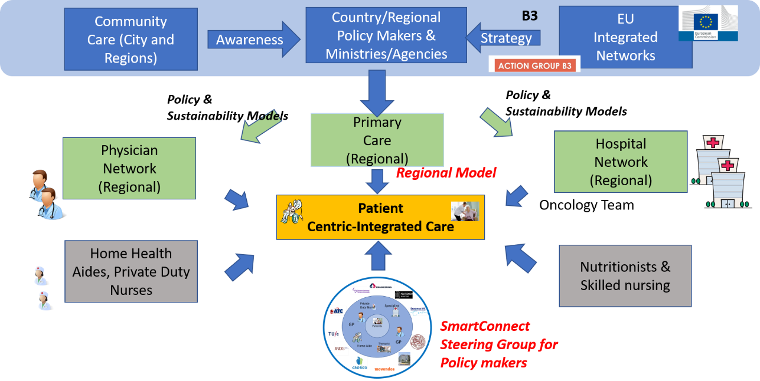

Figure 6: SmartConnect Steering Group for Future Sustainability and Scalability of Processes

SmartConnect aims to set up steering committee consisting of senior clinical leaders, regional and community policy makers and care network groups to help with best practices, and also provide a path for sustainability of the Digital solution for Integrating and personalizing care. This steering committee will meet once in 6 months to review the progress made in the SmartConnect project, monitor guidelines being implemented, and suggest areas of improvement for sustaining the overall professional network with low cost digital solutions.

# Implementation

Pilot sites will be specified, deployed and operated over a 42-month project period

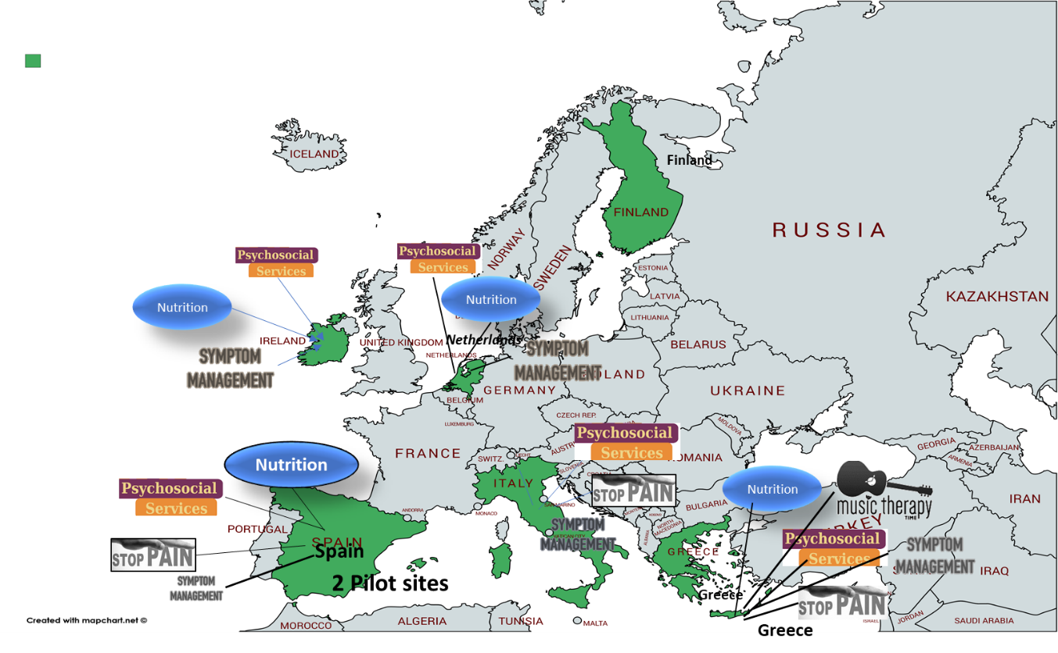

Figure 7: Five Pilot sites across Europe for Palliative Care

* Year 1: Pilot sites will specify the scope of the outcomes, users and performance. The specification can also include the number of patients screened every day, and number of patients actually enrolled into the support and care programs based on their needs. All patients screened will be on the digital platform for support and care (on the standard care plan)
* Year 2: Pilot sites will in operations: ramp-up day by day (and month by month) by adding users per day. Across all the 5 Pilot sites, the number of patients per day to be enrolled into the care programs and patient engagement tools will be around 20. Per month around 600 patients, and per year between 7000 to 8000 patients. In addition, a large number of professionals will begin to be enrolled from Year 2.
* Year 3: Pilot sites will be in full operation through year 3 in monitoring patient engagement performance, overall outcomes, and sharing the results with the Policy makers
* Year 4 (6 months): Pilot sites will ramp-down their operations by month 41, and present results and reports on the overall outcomes and patient experience through mobile apps.

|  |  |  |  |
| --- | --- | --- | --- |
| Pilot Site Validation, Launch and Ops | Patients | Professionals | Integration of users |
| Year 1 (Preparation to launch) |  |  |  |
| Pilot scope, criteria and data integration | 0 | 0 |  |
| Pilot education, training and test | 0 | 0 |  |
| Validation users Q3 | 50 | 100 | 150 |
| Validation users Q4 | 50 | 100 | 150 |
| Validation of operational system |  |  |  |
| Year 2 (Pilot launch and operations) |  |  |  |
| Q1 and Q2 | 3000 | 500 | 3500 |
| Q3 and Q4 | 4000 | 500 | 4500 |
| Outcomes, QoL and Recruitment measures |  |  |  |
| Year 3 (Pilot operations) |  |  |  |
| Q1 and Q2 | 3000 | 500 | 3500 |
| Q3 and Q4 | 4000 | 500 | 4500 |
| Outcomes, QoL and Recruitment measures |  |  |  |
| Year 4 (Pilot operations) |  |  |  |
| Q1 and Q2 | 1500 |  | 1500 |
| Outcomes, QoL and Experience |  |  |  |
| Total users | ~16000 | ~2000 | ~1800 |
|  |  |  |  |

1. **Pilot sites in the first year of the project:** Most institutions may not have the resources (nurses and physicians) to be able to follow up with patients and review their patient charts (records) to see if they meet the Palliative care criteria on a daily basis. This gap in care can be managed by using technology to continuously review the patient records (if they are in electronic form) as treatment and symptom information gets updated on a daily basis or when patient visits occur. The admission criteria for Palliative care includes several factors such as uncontrolled symptoms, metastatic disease, stage of the chancer, unplanned ER and hospitalizations and previous history of hospital stays.
2. **Clinicians can review criteria for palliative care**—clinicians can leverage their defined criteria and follow the European guidelines, and drive clinical workflow to enroll and track patients once enrolled into a Palliative care program. Our project does not enforce any specific criteria for palliative care but recommends some of the practices in palliative care criteria and patient enrollment. Clinicians can choose to employ their respective provider guidelines for Palliative care enrollment and connect patients to a range of certified services (through third-party) such as nutritionists, pain specialists, therapists and occupational support.
3. **Our approach helps clinicians to enroll patients early into Palliative care**. We aim to provide technology-based decision-applications to track patient symptoms in the electronic medical record and intelligently detect adverse events, care gaps and operational events with advance warning. Each patient record can be reviewed (either manually or electronically) as new information comes into the medical record (electronic or physical). two key areas of this approach include the following:
   * Clinician driven decision-making technology to review and enroll patients into palliative care
   * Patient driven (mobile or smart phone based) technology to allow patients to report on symptoms, fill in simple questionnaires and express their needs for psychosocial support.
4. **Our approach enables a review of indicators to reduce unplanned visits to acute settings.** Using the example of uncontrolled symptom identification, our approach would help plan appropriate interventions that would take the risk factors into account, and enroll patients into a Palliative care program. In the study design (in section 2.3) we illustrate the overall project summary with respect to the number of patients, a list of criteria, including disease stage and other conditions. In Figure 7 we show the three main countries where the Pilots are planned to be run for the H2020 project on personalized care.

**Patient population characteristics**

In the table below, we consider several key criteria to be used to identify the right Palliative care candidates for care management, psychosocial support and symptom management.

|  |  |  |
| --- | --- | --- |
| **Characteristics** | **Learning & Implementation cohort** | **Observational cohort** |
| Gender: M/F | M/F (60% / 40%) | M/F (60% / 40%) |
| N = 16000 patients (across 4 hospitals, multi-site and Cancer Centers in Europe | 15000+ patients across the hospitals and cancer centers | 1000 for specific observational trials  (p< 0.01) |
| M = 2000 professional over 2 ½ years across all Pilots to adopt and use technology for patient review/risk and care | 1500 professionals over 2 ½ years | 500 professionals over 2 ½ years |
| Disease areas: Stages 2, 3 and Stage 4 Cancer Populations (Curative and Palliative) | Stages 2, 3 and Stage 4 Cancer Populations | Stages 2, 3 and Stage 4 Cancer Populations |
| Patient groups: All Cancer Patients  Ages: 60-110 | 60-110 | 60-110 |
| Outcome variables:   * Symptom severity * Hospitalization * Urgent care visit * Emergency room visit * Infection (due to surgical procedure) |  |  |
| Baseline Criteria   * Age >= 60 * All Cancer types * At least one uncontrolled symptom (e.g. pain) | Hospital and Cancer Center   1. Hospital specific data on procedures and patient demographics 2. Provider notes | Hospital and Cancer Center   1. Hospital specific data on procedures and patient demographics 2. Provider notes |
| Hospital, Home Health criteria   * Past hospitalizations * Past readmissions * Uncontrolled symptoms (e.g. nausea, vomiting, pain, headache, diarrhea, etc.) * Stage of Cancer condition (Stages III & IV) * Past ER admissions * Total LoS > 3 * Admission from hospice   De-identified   * Provider notes of the patient chart * Symptom information in notes |  |  |

**Data sources and collection**

For this project we consider multiple data sources for identification of Palliative care candidates with in each region. The sources include medical records, patient surveys and patient reported data.

|  |  |  |  |  |
| --- | --- | --- | --- | --- |
| Data Sources | Provided by | Type | Key Attributes | Years |
| Hospital or Cancer Center provided deidentified patient charts | Hospitals and Cancer Centers in Europe | Hospital reported performance measures | * Type of cancer * Stage of cancer * Pain status * Ambulation * Quality of life * Treatment types * Satisfaction * Social needs | 2016-Current |
| Tobacco use surveys | Hospitals or cancer centers | Patient surveys | * Satisfaction scores | 2016-Current |
| PHQ9 or PHQ2  (depression scale) | Hospitals or cancer centers | Depression scale and surveys | * Depression scale | 2016-Current |
| Pain scale | Hospitals or cancer centers | Pain scale surveys and assessment | * Pain scale and ratings | 2016-Current |
| Quality of life assessments (e.g. SF36) | Hospitals or cancer centers | General quality of life-based questionnaires | * SF36 and SF12 | 2016-Current |
| Historical Patient records for the Pilot deployments to ensure low P value and statistically significant measures | Hospital providers in the Netherlands, Ireland, Spain, Greece and Italy | Clinical Charts (physical or electronic) | * Visits * Age * Los * Past visits * Severity of illness * Symptoms | 2016-Current |

**Clinical Process and Workflow**

Our methodology uses the current medical records (EMR if available or physical charts), patient reported data, patient intake on visits and risk assessment from patient surveys conducted by home-care aides or care coordinators to identify risk factors and quantify the need for Palliative care. The following steps describe our approach

1. Clinical data collection—treatment cycle, treatment length, diagnoses, vitals, comorbid conditions, lab tests, clinical notes, depression scale, pain scale, patient surveys—are extracted, transformed, and loaded from the clinical settings (e.g. hospital or cancer center or patient’s home) into a format that is amenable and readily available for clinicians for decision-making.
2. For electronically driven medical records we find that analyses of clinical text require extending augmenting these standardized terminologies and vocabularies. We run a series of heuristics and natural language processing algorithms to identify the risk factors from the written text in the medical records. For paper based medical records we will use standard OCR (Optical character recognition) and other means to process the right criteria to the clinicians to take appropriate action on the patient population.
3. The risk factors for each patient prior to treatment (and during treatment) are loaded into a clinical data warehouse that allows for a number of Palliative care criteria to be run and analyzed. Based on the available data dominant risk factors are gleaned and criteria evaluated for palliative care.
4. ***identification methodology*** on clinical notes driven symptom identification revealed that we can extract critical risk factors from well documented patient charts, and use the finding to review whether a patient is the right candidate for Palliative care. SmartConnect’s digital platform can stratify set of patients, along with their dominant risk factors, supporting evidence, and the kinds of support services they need to endure the treatment complexities, side effects and toxicities.

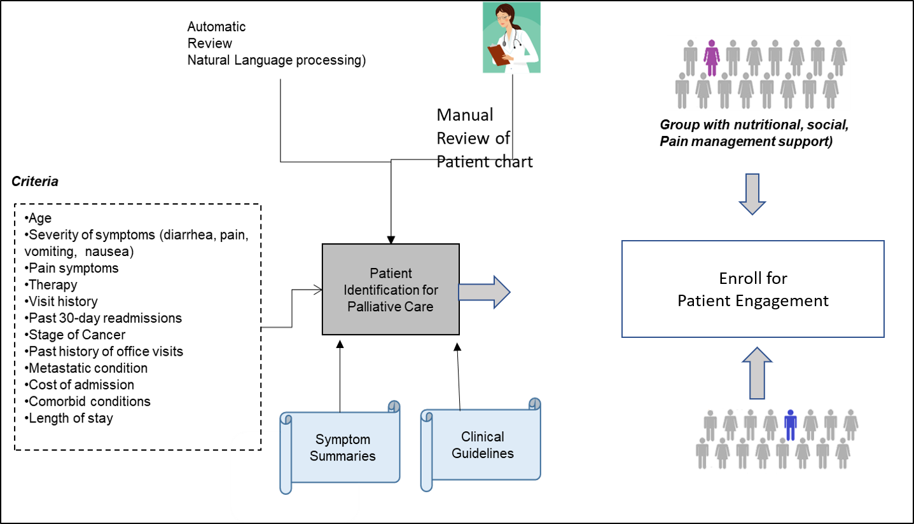

Figure 8: Illustrative decision system for early identification of candidates for Palliative care

**Pilot Implementation Summary**

The following table describes at a high level the implementation of the Pilot decision support platform and summarizes the unique approach to provide a digital platform to integrate professionals (clinicians, service providers, Oncologists, GPs and social workers) to share information about patients and patient care being delivered.

|  |  |
| --- | --- |
| Key steps in the approach | Approach tasks |
| Step A: Pilot Data collection (manual or electronic patient chart/record and any patient reported symptom data) | * Physical record analyses (from physical copies) * Electronical record analyses * Extraction of factors from the medical record * Patient surveys (e.g. PAL-C, PHQ9, PHQ2, Pain Scale) * Patient reported symptom data |
| Step B: Identification using care criteria | * Compute and rank operational risk factors * Employ mode to estimate and predict risk * Select a critical set of patients from the provider list |
| Step C: Patient enrollment and engagement models | * All patients selected for Palliative care will receive the current model of care being offered. A vast majority of the patients will be offered patient engagement (smart phone) apps to participate in more connected care. * Professionals and patients will be enrolled into the digital platform. |
| Step D: Decision and validation by clinicians on the identified Palliative care candidates | * Validate pilot with clinicians and cancer centers * Review patient experience of the two groups * Validate clinical and operations risk factors |

Table 1: Steps illustrating the approach and tasks

## Work Packages

### Work Package Summary

The SmartConnect project is managed over 8 work-packages and work items are spread across several partners over 42 months (3 and ½ years): IT companies, clinical service providers (e.g. nutritionists, pain management specialists), hospitals and cancer centers in Europe. The Work Packages include Pilot requirements, criteria, set-up, patient enrollment, patient consent, enrollment of professionals, care delivery, technology driven assessment, risk stratification, and palliative care monitoring. The Work Packages also include the ability to monitor the Pilot outcomes, professional enrollment ratios, QoL measures and data collection during treatment and palliative care program, and report on the patient outcomes.

|  |  |  |  |  |  |  |  |
| --- | --- | --- | --- | --- | --- | --- | --- |
| Work package no. | Work package title | Type of activity | Lead partic. no. | Lead partic. short name | Person- | Start | End |
| months | month | month |
| 1 | Pilot site requirements, criteria, enrollment size, professionals to be connected and set up. | IA | 11 | ANT | 56 | M1 | M10 |
| 2 | Pilot Process flows, data system, enrollment processes, tracking, and outcomes. Cloud enabled | IA | 5 | TAU | 89 | M2 | M14 |
| 3 | Pilot trust and security and assets for patient privacy in the Pilot system | IA | 2 | JADS-TUE | 47 | M2 | M14 |
| 4 | Pilot smart phone Apps- Patient reported data and feedback using a smart phone application. The app also enables simple surveys (e.g. SF36, Pall questionnaires, SF 12, chat, etc.) | IA | 6 | MOV | 61 | M2 | M14 |
| 5 | Pilot Deployment, daily data integration into electronic medical records, and Operations | IA | 4 | CAPS | 101 | M14 | M40 |
| 6 | Reporting & dashboards for outcomes, and patient QoL performance. | IA | 14 | SAS | 54 | M20 | M40 |
| 7 | Dissemination, education, knowledge transfer, Innovation and training of the Pilot outcomes and progress monitoring | IA | 1 | Industry | 18 | M20 | M40 |
| 8 | Project management across the project and across all Pilots. Individual Pilot managers to work with Coordinator | IA | 1 | ATC | 54 | M1 | M42 |

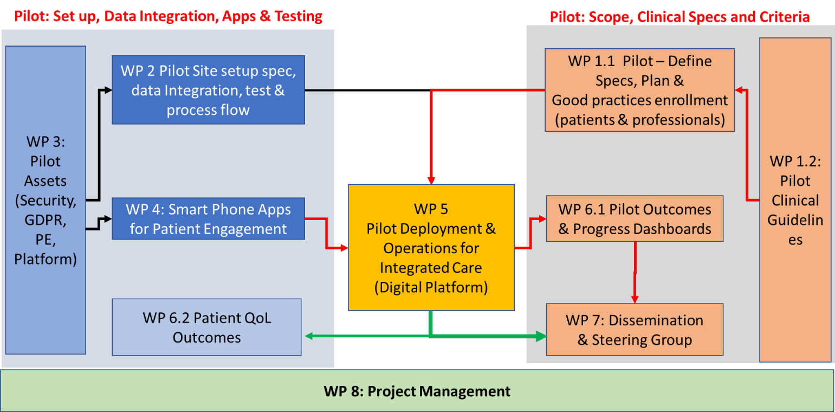

Figure 9: Work Packages for the project and relationships

### Work Package Effort

The SmartConnect project is composed of 8 work packages spread across 14 partners over a 42 -month (3 and ½ years) duration to enable scalable Pilots for Integrated and Personalized Palliative Care for Cancer Patient populations across Europe. The work packages are spread evenly between the clinical and IT (technology partners) over the 3-year period.

The first year is spent on documenting the Pilot requirements, specifications, enrollment criteria for patients and professionals, clinical processes and education. The technology partners have several tasks to build the technology infrastructure, the platform, the mobile applications, the integration of the GDPR into the clinical workflow when communicating with the patients at home.

Figures 9 and 10 show the distribution of effort across the various work packages, and the timeline of completion (Gantt) of each work package, and the transition to the next work package.

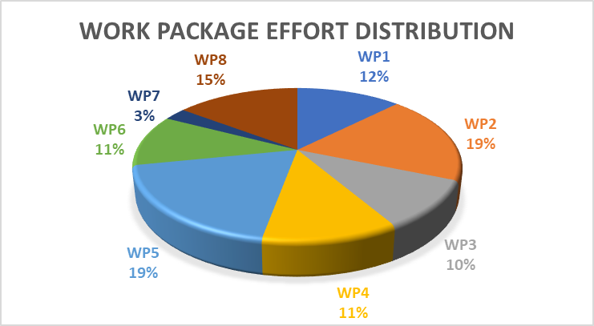

Figure 10: Effort distribution across Work packages

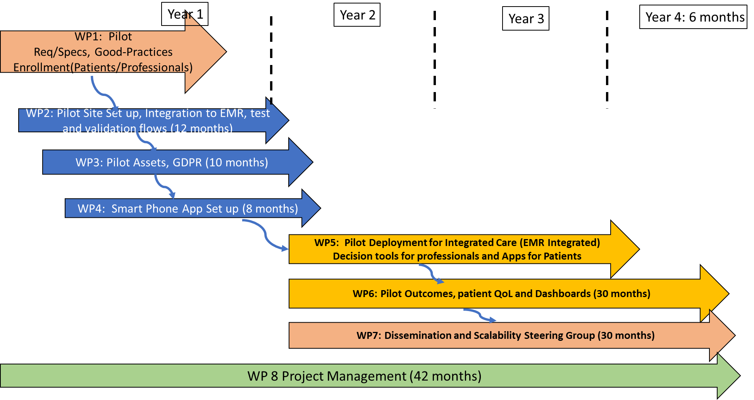

Figure 11: Gantt Chart

### Work Package Details

|  |  |  |  |  |  |  |  |  |  |  |  |  |  |  |
| --- | --- | --- | --- | --- | --- | --- | --- | --- | --- | --- | --- | --- | --- | --- |
| **Work package no.** | **1** | | | **Starting date** | | | **Ending Date** | | | | **Total** | | | |
| M1 | | | M12 | | | | 12 months Duration | | | |
| **Work package title** | Multi-Site Pilot requirements, specifications, guidelines, current state, future state, expected outcomes, clinical pathways, and processes for enrolling patients and professionals on a Digital Platform | | | | | | | | | | | | | |
| **Activity type** | Innovation Action | | | | | | | | | | | | | |
| **Participant** | 1 | 2 | 3 | **4** | 5 | 6 | 7 | 8 | 9 | 10 | 11 | 12 | 13 | 14 |
| **Participant Short name** | ATC | TUE/  JADS | UOC | **CAPS** | TAU | MOV | **EMC** | Eng | PDM | ONC | ANT | APC | SAL | SAS |
| **Person-months** | 2 | 2 | 20 | **6** |  |  | **12** | 4 | 4 | 15? | 15? |  | 12 | 12 |

|  |
| --- |
| Objectives |
| To specify the requirements for scalable Integrated care Pilots across 5 sites in Europe for early Palliative Care, Symptom Management and Psychosocial Services.   * To document the current state of Cancer care services at each Pilot site * Document expected Future state requirement on a Digital Platform for Integrated care. * Document the number of users at each Pilot site, expected enrollment, percentage of professionals enrolled over a common digital platform and expected outcomes. |

|  |
| --- |
| Description of work and role of partners |
| This work package documents each Pilot site’s requirements, clinical criteria and processes per Site (and country) for enrolling at-risk patients for palliative care and support services during and after Cancer treatment. This work package will capture the following:   * Introduction: Hospital/Clinic summary or Care group summary * Current state of the Cancer care for Palliative and Curative stages * Short summary on how are patients enrolled * Current *gaps at the Pilot sites to improve patient engagement and efficiencies of professionals* * Size of the Pilot and specifications (patients and professionals integrated) * Expected Pilot outcomes (e.g. adoption of technology, ratio of professionals enrolled) * Expected Patient QoL, Communication and Experience outcomes * Value needed from the Pilot sites (efficiency of professionals, reduction in negative outcomes) * Recommended guidelines for Integrated care for patients and professionals   T1. Early Palliative Care and Symptom Management at the Department of Medical Oncology of the  *University Hospital of Heraklion, Crete, Greece:* Current State at UoC The University Hospital of Heraklion is a 700 inpatient beds tertiary care medical facility which was inaugurated in 1989 and provides advanced medical services for the population of Crete and surrounding islands. It includes a Department of Medical Oncology, a Department of Surgical Oncology, a Department of Radiotherapy and a weekly Multidisciplinary Tumor Board. The Department of Medical Oncology of the University Hospital of Heraklion provides state-of-the art oncological services to cancer patients.  The Department is staffed with 3 academic and 5 clinical medical oncologists as tenure clinicians and 7 medical oncology residents in training. The Department comprises of the inpatient unit, the outpatient chemotherapy unit and the outpatient clinics. The inpatient unit has 45 beds and receives 2500 admissions a year. The outpatient chemotherapy unit has 23 reclining chairs and beds where 9000 treatments a year are administered. *The outpatient clinics serve 7500 patient visits a year including 1000 new cancer cases*. The Department also includes a very active Clinical Trial Unit with extensive experience in phase I, II, III and IV international clinical studies of novel therapies. The Department is also closely associated and collaborating with the Laboratory of Translational Oncology which is located in the nearby Medical School of the University of Crete. Many clinical and translational studies have been conducted in the Department and the Laboratory and published in prestigious journals.  Currently there is a home-based palliative care service for oncology and hematology patients operated by the hospital which serves patients with cancer living in the metropolitan area of Heraklion and the area surrounding the University hospital. It consists basically of oncology nurses who visit cancer patients once or twice a week at their homes and check on the following items:   * Vital signs * Symptom monitoring (new and old) * Physical findings * Medicine administration (oral and subcutaneous route) * Reporting of side effects * Blood draws for laboratory tests * Port-a-cath and pic line maintenance * Pain relief and physical discomfort   The decision on who should enroll on the program depends on the patient status and special medical needs, place of residency, input from the treating physician and the frequency of recent hospital visits for emergency admissions. Priority is given to non-ambulatory patients and terminally ill patients. The enrollment in the program is approved by the hospital administrative committee for a period of up to six months with the possibility of renewal if deemed necessary. The program is supervised by a senior medical oncologist and the hospital head nurse. Future State with Digital Platform and Smart Phones for Integrated Care With the digital platform and smart phones, the program will expand to enroll up to 200 cancer patients in a period of 24 months. Of them, half will go on the innovation arm and use the technological assistance and smart phones to report on their current symptoms, physical status, inquiries and emergencies and accept proper guidance and medical attention and the other half will serve as controls by using the existing service. Patient reported outcomes (PROMs) and medical events (hospital emergency admissions and clinical outcomes) will be recorded and compared between the two arms to assess the potential advantage of the innovative digital platform approach over the traditional existing one.  Pilot site requirements and specifications   * Number of patients to be screened electronically per year: 1000 * Number of patients to be enrolled into the Pilot sites for patient engagement = 200 * Number of professionals to be enrolled: between 20 to 50 * Number of external GPs: 10-20   Pilot Team:  The program will be implemented by the dedicated staff consisting of   * a general practitioner (and pain specialist), * two visiting nurses, * a nutritionist, * a psychologist, * a secretary   These staff members will be visiting the patients for on site assessment and will provide problem solving guidance and monitoring of their status. They will also ensure that the smart phone devices and the digital platform will be exploited to the full extent and benefit of cancer patients.  Moreover, the program will be supplemented by the availability of an art therapy option for appropriate and susceptible patients who wish to participate in activities such as literature text reading, picture drawing, personal music listening and theatrical performance and drama therapy. These activities are already in progress and available for inpatients and patients receiving treatment in the outpatient chemotherapy unit but will be expanded to reach out to cancer patients enrolled on the program.  Pilot site Technology needed   * Quality of life results with alerts to clinical team. * Advanced technology for patients and professionals * Adoption of technology by the patients * Video chat with oncology nurses * Sharing digital wound photo’s / development in a secure digital environment * Sharing of information across professionals (GP’s included)   Pilot Outcomes:   * Symptom reduction (e.g. fatigue, pain) * Adoption of patient engagement tools (e.g. percentage) * Patient experience (care provided) * Timeliness of care (improvement due to digital platform) * Falls reduction * Emergency room visit reduction * Hospitalization reduction (by 10%) * Visits to home (reduction by 10%) * Cost per unit time reduction per patient supported * Ratio of professionals to patients * Patient satisfaction * Self-management percentage (how many can self-manage vs need care) * Integration of Professionals (improve by 90%) to the Digital solution * *Sustainable model to expand to all Cancer patients for Integrated Care*   T2. Palliative Care at Erasmus-MC, Netherlands for Head and Neck Cancer Patients. Pilot Site  *Current State and Future State* Current State of the Expert Center:Best Practice from Erasmus Medical Center Rotterdam for Palliative Care Expert center Palliative Care Head & Neck Cancer (HNC)   * High quality of psychosocial care team * Dedicated oncology nurses * Multidisciplinary team with psychologist, dieticians, speech therapists, etc.   Value based healthcare:   * PROM structure in place since 2013 for HNC patients in the curative, recurrence and palliative phase and experience in organizational, logistics and technical supported needed for implementing this structure * Combination of data gathering and sharing results * Dashboard integrated in electronic medical record * The palliative PROM is the PAL-C 15 from EORTC-group   Need for advanced analytics: Current state of Prognostic modelling   * Model for curative phase will be tested this spring and used in trial summer 2019 * Model for palliative phase is in development   Team: Physician-patient communication outcomes   * Educational structure in place for all junior doctors * Researchers involved in impact of patient engagement in palliative care HN cancer * Case Manager * GP * Relatives   Expert Center goals   * Symptom management * Recurrence assessment * Goal disturbance and self-efficacy * Clinical prediction of survival   Enrollment Criteria   * Patient of an incurable head and neck tumor or when the patient has refused curative treatment. A head and neck tumor can be incurable for several reasons: inoperability plus no other curative treatment options, distant metastasis, the presence of severe comorbidity, and/or poor performance status of the patient.  Future State with Digital Platform: Integrated Care and Smart Phone/Engagement Patient engagement and empowerment to include Smart phone apps for improved communication and timely symptom information relayed to the Palliative care team, GPs and other care providers.  Pilot Team: The program will be implemented by the Expert Center   * High quality of psychosocial care team * Dedicated oncology nurses * Multidisciplinary team with psychologist, dieticians, speech therapists, etc. * External GPs to be notified (electronically)   Pilot site requirements and specifications   * Number of patients to be screened: 600 per year * Number of patients to be enrolled into the Pilot sites for patient engagement = 100-150 * Number of professionals to be enrolled between 20 to 50 * Additional professionals include external GPs   Pilot site Technology for patient PROM results   * Quality of life results with an alert to the Expert Center with other devices other than the standard computer, e.g. digital watch, or app, or iPad. * Advanced technology for patients and professionals * Adoption of technology by the patients * Having quick (face time?) contact with our oncology nurses * Platform for easy contact with peers (related to the Dutch Patient organization?) * Sharing wound photo’s / development in safe digital environment * Easy sharing info with GP’s   Pilot Outcomes:   * Symptom reduction (e.g. fatigue, pain, malnourishment) * Adoption of patient engagement tools (e.g. percentage) * Timeliness of care for uncontrolled symptoms (patient symptom feedback) * Falls reduction percentage (change) * Emergency room visit reduction * Hospitalization reduction * Visits to home (reduction by 5 to 10%) * Cost per unit time reduction per patient supported * Ratio of professionals to patients in the Pilot * Integration of Professionals Digital solution * Easy sharing (% and efficiency) of accurate and reliable information with GPs   T3. Palliative Care ANT-Eubiosia, Italy Pilot Site  *Current State and Future State*  ANT is the largest NGO offering Cancer Care services for free at Patients homes in Italy. Current State at ANT:Best Practice B3  * Expert center * Current Team * Value provided * Number of patients managed per Day * Number of professionals * Enrollment Criteria (current)  Future State with Digital Platform: Integrated Care and Smart Phone/Engagement Patient engagement and empowerment to include Smart phone apps for improved communication and timely symptom information relayed to the ANT’s Palliative care team,  Pilot Team: The program future at ANT   * Your future team * Your future program to empower patients * Your future program to add more professionals * Processes that you expect to improve and add   Pilot site requirements and specifications   * Requirements for your Site? * Expected value from the Pilot * Number of patients to be screened: 10000 per year * Number of patients in the Pilot for patient engagement * Number of professionals to be enrolled between   Pilot site Technology for patients   * Smart Phone apps? * Patient engagement processes * Digital wound management (for Cancer patients with surgery)   Pilot Outcomes   * Symptom reduction (e.g. fatigue, pain, malnourishment) * Adoption of patient engagement tools (e.g. percentage) * Timeliness of care for uncontrolled symptoms (patient symptom feedback) * Falls reduction percentage (change) * Emergency room visit reduction * Hospitalization reduction * Visits to home (reduction by 5 to 10%) * Cost per unit time reduction per patient supported * Ratio of professionals to patients in the Pilot * Integration of Professionals Digital solution * Easy sharing (% and efficiency) of accurate and reliable information with GPs   T4. Palliative and Curative Care at Oncoavanze, Spain  Current State and Future State  ONC is a Center of Comprehensive Oncological Assistance that addresses cancer in all phases: prevention, diagnosis, treatment, follow up visits, and recovery. ONC was founded in 2010 in Seville, south of Spain. ONC goals are: offer the best professional attention of the patient during their treatment, help them achieve a better quality of life as well as to return to their daily lifestyle and give support to the patient and their relatives, in the sense of consult visits, personalised attention, and psychological treatment.  ONC works in the private sector, leads the Department of Medical Oncology in the main private Hospitals and Clinics in Seville (QuironSalud Sagrado Corazón (126 beds), QuirónSalud Infanta Luisa (115 beds), Vithas Nisa Aljarafe Hospital (360 beds) and Viamed Hospital (100 beds). ONC treats their patients in 3 Chemotherapy Units. Moreover, ONC offers physical activity and rehabilitation programs in order to improve the quality of life of cancer patients. There are specific training programs for patients such as Neuromuscular Electrical Stimulation (NMES), Nordic Walking and Deep water running under an agreement with University of Seville to use the SADUS Sport Center and Sport Lab to assess physical function.  ONC has a multidisciplinary team of experts (27 professionals) including oncologist (6), hematologist (2), general doctors (2), nurses (5), psychologist (1), nutritionists (2), physical activity expert (3) and support staff (6). Also, the group works in close collaboration with specialists renowned in the areas of surgery, radiation therapy, Pulmonologist, internal medicine, urology, digestive, Neurology, etc.  ONC has more than 700 new adult cancer patients per year, 10.000 follow ups and 3.500 chemotherapy treatments per year. The recruitment of patients in Oncoavanze mainly comes from our prestige of renowned oncologists in Andalusia, derivation of patients from other professionals (surgeons, internal medicine, urology, etc.) and health insurance companies. Patients are recruited locally and from the south of Spain.  ONC offers the following services: comprehensive diagnosis and treatment of cancer early diagnosis, genetic counselling for family members of the patients or for people that can have hereditary predisposition to cancer, second medical opinion, psychological support, specialised oncology nursing, physical exercise programs to improve the quality of life of the cancer patient and help them return to their normal life, recovering lost functionalities due to treatment and surgery and specialised nutrition in Oncology and lymphedema. Future State with Digital Platform: Integrated Care and Smart Phone/Engagement The Digital Platform with Integrated Care and Smart Phone engagement will improve the comprehensive care of oncological patients with the different specialists necessary for full attention: oncologists, GPs, internists, nurses, nutritionists and social assistance, using mobile applications and technology that allow connectivity with effective resolution of the needs of these patients and with the professionals. Patients anticipating future risks through advance protocols. Furthermore, it will also provide to the patient a greater control and the possibility to contact the professional who may need depending on their situation.  Pilot Team:     * Your future team: The program will be implemented by the expert staff: * High quality of medical care team * Dedicated health care professional * Multidisciplinary team with psychologist, nutritionist, and physical rehabilitation * Administrative support staff   Pilot site requirements and specifications   * Expected value from the Pilot: Engagement and empowerment of cancer patients ≥60 years non-palliative newly diagnosed or relapsing patients under treatment protocols for improving their quality of life throughout intensive symptom management. * Number of patients to be screened (all patients): 600 per year * Number of patients in the Pilot site for patient engagement 150 * Number of professionals to be enrolled between 20-50   Pilot site Technology for patients   * Quality of life results with alerts to clinical team. * Advanced technology for patients and professionals * Adoption of technology by the patients * Video chat * Sharing digital wound photo’s / development in a secure digital environment * Sharing of information across professionals (GP’s included) * Smart Phone apps * Online consultation with health care team * Schedule visits * Digital wound management (for Cancer patients with treatment)   Pilot Outcomes   * Improve attention with early care and reduce the risk of oncological treatment * Improvement of oncological results by pathology * Prevention of malnutrition risk * Prevention of anxiety states, depression, etc. * Adoption of patient engagement tools (e.g. percentage) * Timeliness of care for uncontrolled symptoms (patient symptom feedback) * Falls reduction percentage (change) * Emergency room visit reduction * Hospitalization reduction * Ratio of professionals to patients in the Pilot * Integration of Professionals Digital solution * Easy sharing (% and efficiency) of accurate and reliable information within pilot team.   T5. Care Groups, NHS Scotland or Ireland  Current State and Future State Current StateBest Practice  * Current Team * Value provided * Number of patients managed per Day * Number of professionals * Enrollment Criteria (current)  Future State with Digital Platform: Integrated Care and Smart Phone/Engagement Patient engagement and empowerment to include Smart phone apps for improved communication and timely symptom information relayed to the Palliative care team,  Pilot team: The future program   * Your future team * Your future program to empower patients * Your future program to add more professionals * Processes that you expect to improve and add   Pilot site requirements and specifications   * Requirements for your Site? * Expected value from the Pilot * Number of patients to be screened * Number of patients in the Pilot for patient engagement * Number of professionals to be enrolled between   Pilot site technology for patients   * Smart Phone apps? * Patient engagement processes * Digital wound management (for Cancer patients with surgery)   Pilot Outcomes   * Symptom reduction (e.g. fatigue, pain, malnourishment) * Adoption of patient engagement tools (e.g. percentage) * Timeliness of care for uncontrolled symptoms (patient symptom feedback) * Falls reduction percentage (change) * Emergency room visit reduction * Hospitalization reduction * Visits to home (reduction by 5 to 10%) * Cost per unit time reduction per patient supported * Ratio of professionals to patients in the Pilot * Integration of Professionals Digital solution * Easy sharing (% and efficiency) of accurate and reliable information with GPs |
|  |

|  |
| --- |
| Deliverables (brief description) and month of delivery |
| D1.1 Pilot criteria, clinical processes and scenarios per Pilot Site (M4)  D1.2 Detailed report on enrolment methods per Pilot site (M4)  D1.3 Detailed report on outcomes expected (criteria) – Pilot site (M6)  D1.4 Pilot site user summary (Patients and Professionals) (M12) |

|  |  |  |  |  |  |  |  |  |  |  |  |  |  |  |  |  |  |
| --- | --- | --- | --- | --- | --- | --- | --- | --- | --- | --- | --- | --- | --- | --- | --- | --- | --- |
| Work package no. | 2 | | Starting date or event | | | | M2 | | | | | M14 | | | | | |
| Work package title | Pilot Set up, Enrollment Criteria set up, patient and professionals registration process, test and validation | | | | | | | | | | | | | | | | |
| Activity type | Innovation Action | | | | | | | | | | | | | | | | |
| Partic. No. | 1 | 2 | | 3 | 4 | 5 | | 6 | 7 | 8 | 9 | | 10 | 11 | 12 | 13 | 14 |
| Partic. Short name | ATC | JADS/TUE | | UOC | CAPS | TAU | | MOV | E-MC | UM | Eng | | ONA | ANT | AIP | SAL | SAS |
| Person-months per partic. | 2 | 2 | | 12 | 36 | 18 | | 3 | 4 | 4 | 4 | |  |  |  |  |  |

|  |
| --- |
| Objectives |
| Define the overall architecture of the software platform, identify the business processes and the deployment strategies across the different sites. |

|  |
| --- |
| Description of work (possibly broken down into tasks) and role of partners |
| Key areas of the work package are as follows:   * Digital platform architecture * Business process management * Cloud and fog computing models for enabling business/clinical processes * Processes and workflow at each Pilot site * Enrollment processes for patients and professionals   In this WP we aim at defining the overall architecture of the digital platform, to identify the different processes, how to orchestrate them and to how deploy the information systems across the multiple sites.  ***T.2.1 Definition of the System Architecture***  In this Task we will identify the overall architecture for the digital platform, based on the requirements identified in WP1. This task will be executed in two rounds. In the first round, we propose a first version of the system architecture. The architecture will be based on existing and validated technologies, including tools and components specifically developed for data-intensive systems. In the second round, after the identification of the business processes in Task 2.2, we will refine the system architecture and propose a final version, based on the overall needs. The system will be based on cloud-native architectures such as microservices and functions. Figures below show an example of the overall system’ interaction and main components.  T2.2 Current State of the integrated care platform  T2.3 Future State with Digital Platform and Smart Phones  ***T.2.4 Baseline Architecture and Modules***    Figure 12: Pilot Platform enhancements and integration  ***Pilot System Interoperability with Existing Technologies***    Figure 13: System Architecture  Implementation of clinical criteria, consent, rules and enrollment, and clinician facing tools for daily worklist management of patients in the Pilots. The overall architecture should consider also the implementation of clinical criteria, consent, rules and enrollment, and clinician facing tools for daily worklist management of patients in the Pilots including:   * Identification and set-up of procedures and workflows at each Pilot site * Pilot site user population (Patients and Professionals) * Site specific demographics data system (e.g. services) * Pilot enhancements to ensure site specific workflows with clinical for enrolling patients for palliative care and support services during and after treatment. * Site specific EMR integration specifics (e.g. FHIR interfaces or JSON) to pull and push data * ETL processes for each EMR or clinical data application (in use at the Pilot sites) * Pilot set up to integrate (interoperate) patient data from site specific EMRs   ***T2.2 Business process identification and service mapping***  In this task we will identify the different business processes and how to map them to the platform. The goal is to identify a set of highly cohesive and loosely coupled services that will allow different teams to develop and deploy them independently. The mapping will be performed using standard business process modelling language (BPML). Example or processes are the patient enrollment, or the patient communication with GPs, but also technical business process related to the Specialized ETL processes for each EMR or clinical data application used at the pilot sites.    ***T2.3 Service Orchestration and Cloud Enabling***  In this task we will investigate the most suitable approach for deploying the system to the cloud, and to orchestrate and coordinate the different services efficiently |

|  |
| --- |
| Deliverables (brief description) and month of delivery |
| D2.1 The overall Platform Architecture, business processes and their orchestration(M8) |
| D2.4 Platform enhancements (clinical processes and specific microservices APIs (M12) |
| D2.5 Cloud enablement of the data and process platform - Testing and Validation (M14) |
|  |

|  |  |  |  |  |  |  |  |  |  |  |  |  |  |  |  |  |
| --- | --- | --- | --- | --- | --- | --- | --- | --- | --- | --- | --- | --- | --- | --- | --- | --- |
| Work package no. | 3 | | | Starting date or event | | | | M2 | | | | | End date; M14 | | | |
| Work package title | Software-Assisted Trusted, Secure, and GDPR-Compliant Computing | | | | | | | | | | | | | | | |
| Activity type | IA | | | | | | | | | | | | | | | |
| Partic. No. | 1 | 2 | 3 | | 4 | 5 | 6 | | 7 | 8 | 9 | 10 | 11 | 12 | 13 | 14 |
| Partic. Short name | ATC | JADS/TUE | UOC | | CAPS | TAU | MOV | | E-MC | UM | Eng | ONA | ANT | AIP | SAL | SAS |
| Person-months per partic. | 4 | 72 | 4 | | 2 |  |  | | 1 |  |  |  |  |  |  |  |

|  |
| --- |
| Objectives |
| The work package will deliver safe, secure, and private-by-design methods for patient communication with clinicians (including their GP and other service providers) and to support the software transactions required across the SmartConnect architecture. More specifically the work package will deliver: (1) a blockchain-oriented design to support trusted eHealth computing; (2) GDPR-compliant policy deployment and monitoring; (3) large-scale information processing which is guaranteed to be *private-by-design.* |

|  |
| --- |
| **T3.1 Blockchain-oriented design and deployment of eHealth solutions.** This task will identify and refine specific eHealth design patterns to be used for trusted computing in the SmartConnect ecosystem and implement the proposed design patterns using a generic prototype from previous and related work. In the scope of this task, the work will focus on reusing baselines from the **B3 Integrated care European partnership.**  Blockchain technology relies on pseudoanonymity (replacing names with identifiers) and public key infrastructure (PKI), keeping the privacy of the users. Blockchain potential in healthcare and research includes use cases such as privacy preservation for predictive modeling (WP2, WP6), increasing interoperability between institutions at a large scale (WP2, WP6), immutability of health records, health insurance claim process improvement, health information exchange (WP2), healthcare delivery models with artificial intelligence (WP2), identity management (WP2), monetization strategies and data provenance requirements.  We will assess design promises and perils of permissioned blockchain alternatives (those requiring the network nodes to validate) such as Hyperledger Fabric or NEM blockchain[12], but also evaluate the blockchain as an asset, ownership or identity-binding infrastructure, and design our eHealth solution on top of a built-in trust-based component by means of approaches such as Blockstack[13].  **T3.2 GDPR-compliant eHealth information processing.** This task will focus on incrementally refining and controlling transactions stemming and as supported by the trusted platform in T3.1 in a privacy-aware fashion, in line with restrictions and regulatory actions dictated by the General Data Protection Regulation (GDPR).  This involves the different information exchanges present in ***Figure 14***, in which the trusted system administrator can grant key pairs to the Clinical teams (Step 1), configure the roles and GDPR policies to be enforced by the underlying blockchain (Step 2), and provide key pairs to external GPs (Step 5), home health nurses (Step 6), Social workers (Step 7), Nutritionists (Step 8) and Home Health Aid or Therapist (Step 9) based on the aforementioned roles.  To achieve such degree of interoperability in eHealth, the underlying platform should be able to maintain GPDR-compliance in the following levels: 1) **Foundational interoperability** that enables eHealth information exchange without requiring the ability for the receiving party to interpret the data. This means, on top of the underlying blockchain there will be mechanisms to marshall/unmarshall information packages automatically, and the stored/transferred information should cope with the privacy statements.  2) **Structural interoperability** that defines the formats of exchanged clinical data and ensures that received data are preserved and can be interpretable at the data field using the predefined formats. This is achieved by providing the mechanisms to automatically deal with existing protocols and standards for eHealth information exchange such as HL7 3) **Semantic interoperability** that allows for interpretation of data exchanged by not only syntax (structure) but also semantics (meaning) of the data. To move towards semantic interoperability, our platform will support data schema standards like FHIR as described above.  Again, in the scope of this task, safe and trustable computing baselines defined previously in EU H2020 project DICE will be reused. More specifically, the task will refine holistic monitoring technology from project DICE to cope with GDPR-specific computations monitoring.    **Figure 14: Use case for the eHealth platform**  **T3.3 Private-by-design eHealth computing.** This task will address the need for private-by-design large-scale information processing, inference, machine-learning or other computational intelligence approach. Leveraging on tools and techniques defined in the scope of T3.1-3.2, the task will incrementally specify private-by-design software verification properties to be enacted and formally-verified by means of runtime model-checking techniques. Such verification@runtime steps will be performed upon test blockchain networks with controlled parameters – *a la* Rinkeby[14] but for the underlying blockchain platform.  Special focus will be put on assessing privacy, since the use of blockchain technology introduces several perils. The pseudonymous property of transactions currently allows for data forensics, or inferring patterns of treatment from frequency analysis. Without any disclosure, one could infer that some entity has repeatedly interacted with another network entity through analysis of network traffic. We will leverage techniques for improving obfuscation while preserving auditability on the blockchain – e.g., by means of protocols similar to Zerocoin/Zerocash but for general purpose (the former are intended particularly for cryptocurrencies). One potential improvement comes along by adopting a “permissioned” blockchain structure, where only pre-approved, whitelisted nodes are allowed read access to the ledger. This would prevent rogue actors from extracting frequency-based insights from the blockchain records. Furthermore, encryption can be introduced in the off-blockchain data syncing steps to safeguard against accidental or malicious content access. While outside the scope of the initial pilot system, a rigorous k-anonymity analysis of privacy-preserving query construction is needed, for release of the aggregated research data to medical research “miners.”  Previous baselines for these tasks will be gathered starting from the Soloist large-scale runtime verification tool well within the scope of the consortium.  **T3.4 Large-scale solution evaluation.** Theprototypes refined as part of T3.1-3 will be tested and continuously improved throughout the duration of the project and beyond.  This task aims at refining the DevOps and DataOps pipeline to enact such continuous improvement by leveraging on existing data pipelining components and architectural styles. In particular, we will aim to:   * Evaluate and improve performance and efficient resource usage; * Perform macro and micro optimizations which help with performance improvements; * Solve challenges related to durability, availability and concurrency.   We will as well define/adopt metrics for evaluating the eHealth information processing workflow as a whole, by providing the means to monitor, for example:   * Entire workflow is HIPAA compliant: we should limit the storage of encrypted sensitive data on the blockchain. For example, by storing some unidentifiable or encrypted metadata to refer to actual patient health information. Likewise, it may store only minimum resource required to obtain/exchange sensitive data through a trusted channel, to query/retrieve data sources outside the blockchain while ensuring they are genuine and untampered. * Framework employed needs to support Turing-complete operations: the underlying blockchain platform should contain programming features capable of solving any computation problem. * Support for user identification and authentication. Two types of participants require identification and authentication in healthcare: patients and healthcare professionals with substantially different features -- the former is significantly more, whilst the later have much more knowledge of the type of eHealth information handled by the system. * Support for structural interoperability at minimum (and ideally semantic interoperability): this enables the exchange of clinical data and interpretation of received data given the structures or formats implemented, and be able to work with popular data standards such as FHIR. * Scalability across large populations of healthcare participants: Since our system may need to provide services for thousands of users, it must be scalable, so it must be the underlying blockchain platform, for instance, how much information can be managed before the blockchain platform terminates further operations to prevent it from a potential malicious/DDoS attack? * Cost-effectiveness: what will be the costs associated with the services and how will those costs compare with existing systems that are centralized and proprietary? Cost is particularly relevant when providing services for large patient populations. Likewise, is the new blockchain-based model more cost-effective than conventional solutions? Furthermore, what will be the cost of maintaining and upgrading the new system if/when necessary? * Support of patient-centered care model: our eHealth system should ultimately grant patients easier access and control over their own medical data; this may include health information self-reporting, access of personal medical records or prescription history from different providers, auditing existing accesses to patient health records, and the ability to share or revoke access to patients’ own medical data. |

|  |
| --- |
| Deliverables (brief description) and month of delivery |
| D3.1 Open source library assessment and inclusion in the data platform and mobile apps |
| D3.2 Implementation of GDPR policies and security protocols |
| D3.3 Testing, Validation and Deployment upon a prototype platform |
| D3.4 Implementation using a services model to enable any application to leverage the GDPR modules |

|  |  |  |  |  |  |  |  |  |  |  |  |  |  |  |  |  |
| --- | --- | --- | --- | --- | --- | --- | --- | --- | --- | --- | --- | --- | --- | --- | --- | --- |
| Work package no. | 4 | | | Starting date or event | | | | M2 | | | | | M14 | | | |
| Work package title | Mobile Apps for Patient Feedback and Reported Data | | | | | | | | | | | | | | | |
| Activity type | IA | | | | | | | | | | | | | | | |
| Partic. No. | 1 | 2 | 3 | | 4 | 5 | 6 | | 7 | 8 | 9 | 10 | 11 | 12 | 13 | 14 |
| Partic. Short name | ATC | JADS/TUE | UOC | | CAPS | TAU | MOV | | E-MC | PDM | Eng | ONA | ANT | AIP | SAL | SAS |
| Person-months |  |  | 4 | | 6 | 2 | 39 | |  |  |  |  |  |  |  |  |

|  |
| --- |
| Objectives |
| Develop and deploy mobile Apps on Smart Phone (purchased for the patients) to enable patients to a) communicate with the care team to send symptom information, to get advice and to send pictures of wounds to care team, b) enable the patient to find service providers supporting care (e.g. psychosocial services, nutritionists, social support), c) schedule visits related to care, and to d) reach out and get support from other patients and patient focus groups. |

|  |
| --- |
| Description of work (possibly broken down into tasks) and role of partners |
| Smart Phone applications play a key role in empowering the patients, engaging them better to the care and to improve communication with the care team to provide direct feedback and any data to the clinicians.  The integration of patient facing applications with services is of utmost importance to Hospitals/Cancer centers involved in care coordination and integrated care. Timely patient engagement apps have shown to improve care, connectivity and reduce unplanned Emergency room visits.    Mobile applications built in WP5 include:  a) **Patient communication**: This application enables the patient to communicate with the care team to send symptom information, to get advice and to send pictures of wounds to care team. Secure video calls, messaging and chat are supported. Patient can also answer questionnaires related to care.  b) **Network of service providers:** This application enables the patients to see the list of possible service providers providing and supporting care (e.g. psychosocial services, nutritionists, social support), to contact them and to include them into the care. List of possible service providers is provided from the SmartConnect Data Platform, and the list is created and adapted based on the care plan and the personal situation of the patient.  c) **Patient calendar for scheduling visits related to care**: This application provides the possibility for scheduling visits and appointments (e.g. video calls) with the care providers.  d) **Patient social network**: This application enables the patient to reach out and get support from other patients and patient focus groups using a private social network.  All these applications are combined together to form one patient portal, accessible from Smart Phone application. The applications are next described in more detail.  **Patient Apps** Patient communication Patient communication enables communication between the patient and care providers. Secure video calls, messages and chat are provided. Application gives the patient an opportunity to send to the care team information about symptoms such as pain level, fatigue and daily living status. Application also enables the patient to take pictures with the Smart Phone and to send them to the care them. An important use case is the pictures of wounds and delivery of the pictures for the care team for annotation, analysis and inclusion to the medical records.  Application also includes the surveys and questionnaires supporting the care and providing information about the health status of the patient. Questionnaires include e.g. SF-36, PHQ9, depression questionnaires, nutrition-related surveys and quality of life – related surveys. Application also collects from the Smart Phone sensors information about the activity level of the patient (steps) and enables the patient to follow up his/her weight and to deliver that information for the care team.  The key features include:   * Capability for the patient to make a video call securely with the clinicians and certified service providers * Capability for the patient to send messages and chat with the care providers * Ability for the patient and clinician to review previous video call (buffer or just the previous call) * Ability to send and fill in selected surveys and questionnaires related to care * Follow-up of daily steps using the phone sensors. Showing this information to the patient and sharing it with the care providers * Capability for the smart phone to take a picture of the wound. The picture can be taken by the patient, a home health nurse or authorized family members. Ability to send this picture securely to the clinicians (only). Capability to “Annotate” the wound picture. Capability to push the wound picture and any data to the data-platform (backend) * **Capability for the smart phone to drugs requirement, transport need**  Patient mobile app to see the network of service providers Several caregivers participate in the care process. In addition to medical care, patients also need e.g. the following services: support at home, nutrition, pain management, social support, mental health support, psychosocial services. Based on the care plan, SmartConnect system provides a patient- and situation-specific list of possible certified service providers. Mobile application developed in this task enables the patient to see the list of potential care providers and to contact them.  Key features include:   * Capability for the patient to see a list of GPs, providers, including their hospital Oncologists. * Ability to search a list of GPs, providers, home health and hospitals * Ability to review the ratings of the providers, home health and hospitals – ***NOT Critical*** * Ability for the patient to make a call or contact them via messaging service  Patient calendar for scheduling visits and meetings related to care This application provides the patient calendar about the care events. Calendar information is stored in the Data Platform of the SmartConnect system, which synchronizes it with calendars of the care providers.   * Capability for the patient to schedule appointments, including home visits, hospital visits and video meetings * Ability to see upcoming appointments * Ability to review or cancel appointments * **Ability to find services for the social needs of whole family**   Following flow charts describe some key use cases for including new caregivers to the network and for scheduling visits and meetings:  *Patient to GP:*    *Patient to private duty nurse*:   Patient to home health aide: **Patient social network**  This application gives the patient a possibility to reach out to other patients in a similar situation to get support. Patients can communicate securely and anonymously with other patients who are undergoing similar therapies or palliative care services. Clinicians / nurses can also join the discussions and help moderating the discussions, if needed.  Social networks are automatically formed from the participants of the pilots, who are in similar situations than the patient. List of the patients in each social network is stored in the Data Platform.  The key features of patient social network include:   * Capability for the patient to chat with other patients. Whole network discussions, smaller group discussions and one-on-one discussions are possible * Ability for a patient to enroll and register their family network * Ability for the patient to share their experiences * Ability for the clinicians to see the communication topics and join the discussions * GDPR has a major role to play here.   **Development process**  All applications are developed following an iterative user-centric design process. Language-localized versions are provided for the three pilots. |

|  |
| --- |
| Deliverables (brief description) and month of delivery |
| D4.1 Patient communication app  D4.2. Patient communication application including also questionnaires and activity sensor data collection |
| D4.3 Patient mobile app to see the network of service providers |
| D4.5 Patient calendar for scheduling visits and meetings related to care |
| D4.4 Patient social network |

|  |
| --- |
| Description of work (possibly broken down into tasks) and role of partners |

|  |  |  |  |  |  |  |  |  |  |  |  |  |  |  |  |  |
| --- | --- | --- | --- | --- | --- | --- | --- | --- | --- | --- | --- | --- | --- | --- | --- | --- |
| Work package no. | 5 | | | Starting date or event | | | | M14 | | | | | M40 | | | |
| Work package title | Pilot Ramp-Up, Launch and Operations | | | | | | | | | | | | | | | |
| Activity type | Innovation Action | | | | | | | | | | | | | | | |
| Partic. No. | 1 | 2 | 3 | | 4 | 5 | 6 | | 7 | 8 | 9 | 10 | 11 | 12 | 13 | 14 |
| Partic. Short name | ATC | JADS/TUE | UOC | | CAPS | TAU | MOV | | E-MC | UM | Eng | ONA | ANT | AIP | SAL | SAS |
| Person-months per partic. | 2 | 2 | 12 | | 36 | 18 | 9 | | 4 | 4 | 4 |  |  |  |  |  |

|  |
| --- |
| Objectives |
| To ramp-up, deploy and launch Pilots at all sites. To develop a launch plan at each Pilot site. To operate the Pilots for 30 months (2 and ½ years). To enable clinicians at the clinical settings to review patient charts and enroll patients into the digital platform and patient engagement tools (apps). |

|  |
| --- |
| Description of work (possibly broken down into tasks) and role of partners |
| T 5.1 Digital Platform launch. In this work package a digital platform (Mutli-tenant, each tenant for a Pilot) for population health at each of the Pilots will be set up by CapsicoHealthCare (CAPS) and will enable each Pilot site to enroll patients, and enroll professionals to be able to review, analyze and deliver care to the patients. The data platform is commercial grade system that has been proven across the Globe by CapsicoHealth. The company has been ranked Becker’s Health 2 years in row as one the top 50 innovative companies offering Value based care and Population health platforms and solutions. Each Pilot site can set privacy controls and only allow their respective clinicians and certified professionals to connect to the platform to view patient summaries, see notifications and look up calendar information on events and appointments.  T5.2 Integrated care by connecting the professionals at each Site to review patients or get notifications.   * Pilot sites in the first year of the project: Most institutions may not have the resources (nurses and physicians) to be able to follow up with patients and review their patient charts (records) to see if they meet the Palliative care criteria on a daily basis. This gap in care can be managed by using technology to continuously review the patient records (if they are in electronic form) as treatment and symptom information gets updated on a daily basis or when patient visits occur. The admission criteria for Palliative care includes several factors such as uncontrolled symptoms, metastatic disease, stage of the chancer, unplanned ER and hospitalizations and previous history of hospital stays. * Clinicians can review criteria for palliative care—clinicians can leverage their defined criteria and follow the European guidelines, and drive clinical workflow to enroll and track patients once enrolled into a Palliative care program. Our project does not enforce any specific criteria for palliative care but recommends some of the practices in palliative care criteria and patient enrollment. Clinicians can choose to employ their respective provider guidelines for Palliative care enrollment and connect patients to a range of certified services (through third-party) such as nutritionists, pain specialists, therapists and occupational support. * Our approach helps clinicians to enroll patients early into Palliative care. We aim to provide technology-based decision-applications to track patient symptoms in the electronic medical record and intelligently detect adverse events, care gaps and operational events with advance warning. Each patient record can be reviewed (either manually or electronically) as new information comes into the medical record (electronic or physical). two key areas of this approach include the following:   + Clinician driven decision-making technology to review and enroll patients into palliative care   + Patient driven (mobile or smart phone based) technology to allow patients to report on symptoms, fill in simple questionnaires and express their needs for psychosocial support. * Our approach enables a review of indicators to reduce unplanned visits to acute settings. Using the example of uncontrolled symptom identification, our approach would help plan appropriate interventions that would take the risk factors into account, and enroll patients into a Palliative care program. In the study design (in section 2.3) we illustrate the overall project summary with respect to the number of patients, a list of criteria, including disease stage and other conditions. In Figure 7 we show the three main countries where the Pilots are planned to be run for the H2020 project on personalized care.   T 5.3 Implementation of MDS (minimum data set), consent, rules and enrollment, and clinician facing tools for daily worklist management of patients in the Pilots.   |  |  |  | | --- | --- | --- | | **Minimum Data Set** | | | |  |  |  | | **Attribute** | **Type** | **Description** | | **PID** | **Value (Alphanumeric)** | **Unique identifier for Pilot** | | **EID** | **Value (Alphanumeric)** | **Enterprise EMR identifier (each Pilot's EMR)** | | Age | Value (range) | Age in years (and ranges) | | Gender | Value (unique) | Mulitple options (M, F, N, O) | | Address | Text | Local address | | Admit date | Date | Admission to the hospital | | Martial status | Flag | Status of the patient | | Diagnoses (primary) | ICD10 | Diagnoses | | Secondary diagnoses | ICD 10 list | List of diagnoses | | Treatment type | Adjuvant Therapy | Overall treatment | | Treatment cycle | Cycle of chemotherapy | Cycle length (6 ot 8 weeks) | | Surgery | Text | Summary | | Start of surgery | Date | Date of surgery | | Start of radiation therapy | Date | Date of RAD-ONC | | Start of treatment | Date | Start of treatment cycle | | End of treatment | Date | End of treatment cycle | | Discharge date | Date | Date of discharge from hospital | | PERLID | Value (Alphanumeric) | Patient Engagement Identifier | | Home visit | Start of care form | Intake by skilled nurse | | Home visit | Date | Date of first visit | | Video with care team | Video | Short video (5 to 10 min) | | Pain assessment | Form values | Structured questionnaire (pain index) | | GP visit | Visit date | Visit to the local GP | | Pharmacist visit | Visit date | Pharmacist visit to home | | Social worker visit | Visit date | Social worker visit to home | | Text feedback | Text (free form) | Text feedback on health status | | Text feedback on symptoms | Text (free form) | Pain related free text | | SF 12 assessment | Form | SF 12 assessment from patient | | SF 36 assesment | Form | SF 36 assessment from patient | | Pain assessment | Form | Feedback from Patient | | Nutritionist | Visit date | Date of nutritionist visit | | Pharmacist visit | Video visit | Video with certified Pharmacist | | Image of wound | Wound image | Image of the wound | | Wound status | Form | Form on the wound status | | Schedule of visit | Date | Schedule of future visit | | Schedule of social care visit | Date | Schedule of future visit | | Schedule of community care visit | Date | Schedule of future visit | | Schedule of spiritual care visit | Date | Schedule of future visit | | Generic Assessment | Form | New assessment from patient |   Develop the underlying MDS (shown in the Table above) into the Pilot data warehouse (managed by an experienced group of people at CAPS). The data warehouse will enable the necessary support structures for expanding MDS into a flexible data set for new kinds of patient engagement data. MDS provides the foundation for the Patient engagement record (CAPER) to enable actionable insight for personalising care.   |  | | --- | |  |   T5.4 Implementation process - patients and professionals onto the digital platform on a daily basis  **Implementation Process**  Each hospital and clinic will have their current internal processes and methods to review patient records and determine if they are candidates for early Palliative care. To automate some of the identification process SmartConnect needs to connect to the current hospital (medical record). The data collection can also be done from a patient’s home prior and during the treatment period using simple smart phone-based questionnaires on pain level, anxiety, depression, daily living activities, and related. To meet our objectives, we consider the following:   |  |  | | --- | --- | | Key steps in the approach | Approach tasks | | Step A: Data integration (manual or electronic patient chart/record and any patient reported symptom data) | * Physical record analyses (from physical copies) * Electronical record analyses * Extraction of factors from the medical record * Patient surveys (e.g. SF36, PALL, PHQ9, PHQ2_ * Patient reported symptom data | | Step B: Identification using palliative care criteria | * Compute and rank operational risk factors * Employ mode to estimate and predict risk * Select a critical set of patients from the provider list | | Step C: Patient risk assessment based on chart and patient reported symptom information | * Select patients into two groups (observation and control) * Observation group get palliative care support * Control group has current standard of Oncologic care * Compare the outcomes on sub-populations enrolled into the palliative program compared to the ones who received the current standard of care | | Step D: Decision and validation by clinicians on the identified Palliative care candidates | * Validate pilot with clinicians and cancer centers * Review patient experience of the two groups * Validate clinical and operations risk factors |   Step B: Identification (done by clinicians)  Criteria such as age group, disease type, disease stage, quality metrics, utilization, unplanned visits, symptom information, and treatment type will be analyzed prior to enrolling patients to Palliative care support. Clinicians will be provided with an IT application (e.g. Tablet based) to review the patient criteria on a daily basis to enroll patients into the palliative care program. The enrollment process is shown in Figure 3 and workflow between the clinicians and patients is shown in figure 4.  Step C: Enrollment and risk assessment  Risk assessment based on the patient charts on symptoms and past history of utilization, past history of hospitalizations, past 30-day readmissions (within a 90-day horizon). Once a patient is enrolled in the program the patients can get access to additional services such as nutritional support, pain management care, social support and other psychosocial support.  Steps D: Tracking and validation  We consider the following two groups to compare: a) an ***observation*** group, consisting of patients who are monitored and offered palliative care; b) ***control*** group, where patients who were likely candidates for palliative care but received the current standard of Oncologic care. The two groups will be monitored closely for a short period of time (30 to 60 days). Once the initial trial period is completed all the patients in the observation and control groups will all get Palliative care support to ensure quality outcomes.  **T5.5 Pilot System Operations**  Implementation of clinical criteria, consent, rules and enrollment, and clinician facing tools for daily worklist management of patients in the Pilots.  For the Pilot we will deploy the patient identification protocols (by clinicians) at Cancer Centers to enable early identification for palliative care services. The patients once enrolled will be contacted by the clinicians and support staff to begin palliative care (with consent), and will be requested to use technology to provide feedback on the palliative care services, request new services and monitor the visits to the patient’s home.  The plan is to register pain-specialists who deal with pain management during and post-therapy. These specialists will be able to contact the patients (enrolled in the Palliative care) and offer services, or the patient can connect and request services directly from the specialists. Likewise, nutritionists will be recommended to the patients involved in Palliative care programs, and support will be provided over a period of time starting from the treatment cycle and few weeks beyond the treatment. |

|  |
| --- |
| Deliverables (brief description) and month of delivery |
| D5.1 Report on Pilot set up and process (M4) |
| D5.2 Report on adoption by users (M4) |
| D5.3 Minimum data set for Pilot operations (M4) |
| D5.4 Pilot implementation (M14) |
| D5.5 Pilot operations, performance and automation (M32) |
|  |

Work Package 6

|  |  |  |  |  |  |  |  |  |  |  |  |  |  |  |  |  |  |
| --- | --- | --- | --- | --- | --- | --- | --- | --- | --- | --- | --- | --- | --- | --- | --- | --- | --- |
| Work package no. | 6 | | | Starting date or event | | | | M20 | | | | | M40 | | | | |
| Work package title | Outcomes, Measures, Data Marts and Dashboards | | | | | | | | | | | | | | | | |
| Activity type | IA | | | | | | | | | | | | | | | | |
| Partic. No. | 1 | 2 | 3 | | 4 | 5 | 6 | | 7 | 8 | 9 | 10 | | 11 | 12 | 13 | 14 |
| Partic. Short name | ATC | JADS/TUE | UOC | | CAPS | TAU | MOV | | E-MC | UM | Eng | ONA | | ANT | AIP | SAL | SAS |
| Person-months per partic. | 1 | 0- | 12 | | 16 | 16 | 0 | | 1 | 1 | 1 | 1 | |  |  |  |  |

|  |
| --- |
| Objectives |
| To define measures, metrics and outcomes and corresponding data for reporting.  Integrate dashboard technology over the data warehouse for measure visualizations. |

|  |
| --- |
| Description of work (possibly broken down into tasks) and role of partners |
| SmartConnect proposal aims to enroll 16,000+ patients for the live Pilots across all sites, and enroll over 2000+ professionals to use the common digital platform to access care information and deliver care. The project aims to measure and report on Cost, Outcomes and financial viability on clinician utilization. This work package is responsible for outcomes measure definitions, data elements and dashboards for clinicians to measure and monitoring the health of the patients in the Pilots. The measures are grouped into the multiple categories such as: Pilot metrics for success, patient quality of care (QoL) and utilization (cost).    **T6.1 Pilot performance**  Current adoption by professionals of integrated digitally driven care solutions is less than 10% across Europe, and in some cases less than 1% within a region, and in some progressive countries over 50%. These professionals include not just hospital clinicians, but social workers, public health personnel, GPs, home health aides, nutritionists, therapists, exercise specialists, psychologists, etc. Our aim is to measure the adoption ratio of professionals (within **a region)**   * Total number of professionals integrated at each site * Percentage of clinicians to patients at each site * Percentage of professionals to patients at each site * Percentage of social care workers to patients at each site * Percentage of professionals in the pilot versus overall professionals in the region * Ratio of patients to professionals at each site   **T6.2 Quality of Life**  SmartConnect’s patient engagement tools are world-class technologies proven in Europe to enable patients to do secure video chats, set up appointments, schedule visits, take pictures in a secure way for digital wound assessment (cancer patients with surgery). SmartConnect will measure several QoL measures based on assessments such as SF36, SF12, PHQ9 and related. Through KPS Index (Karnofsky performance status scale) a clinical evaluation done by Physicians. In the case of inability of patients, the assessment could be filled by caregivers, through ADL (Activities of Daily Living), IADL (Instrumental Activities of Daily Living).   * Ability to walk (percentage) * Ability to change clothes (percentage) * % of patients with fatigue * % of patients with ER visits * % of patients with pain medications * % of patients with pain level on high. (such as BPI: Brief Pain Inventory; ESAS: Edmonton Symptom Assessment Scale) * Psychological dimensions (such as POMS-SF)   **T6.3 Patient experience**  SmartConnect aims to analyze experience related measures of patients with smart phones for their communication, feedback and symptom management. It’s necessary to establish an agreed upon range of scores to define a communication as poor, moderate or good.   * % of patients with poor communication with professionals * % of patients with no communication with professionals * % of patients with moderate to good communication with professionals. * % of patients fully satisfied with professional services and consultation * % of patients moderately satisfied with professional services and consultation   **T6.4 Cost per unit measures**  SmartConnect aims to analyze workflows and clinical processes through the digital platform to measure the number of work units (per professional) spent on each of the patients in the Pilot sites.   * Time units spent per professional per patient * Time units spent per patient at home * Time units spent by professionals per patient in clinical settings * Time units spent by therapists at patient homes * Time units spent by therapists in professional settings * Time units spent by professionals offering care through digital connection (e.g. video) * Time units spent by professionals in person   **T6.5 Dashboards (actionable measures)**  Several electronic dashboards will be implemented and provided to all the Pilot sites on quality of life, patient experience, pilot site performance, utilization and costs. A vast majority of the dashboards are already available in the commercial platforms being deployed for the Pilot sites. Additional dashboards have to be implemented on patient experience and units of cost. In addition, Pilot partners such as EMC (Erasmus-MC), SAS (Large Public Hospital in Andalucía, Spain) and ANT (NGO offering Home based care in Italy for Cancer patients) have established a set of KPIs and dashboards as a part of their current care management operations. Some of their best practices will also be integrated into the overall collection of dashboards for the Pilots. This allows for cross-pollination of practices and decision-making around outcomes improvements based on actionable information. |

|  |
| --- |
| Deliverables (brief description) and month of delivery |
| D6.1 Outcomes specification and measures (document) |
| D6.2 Patient quality of life and experience measures (document) |
| D6.3 Report on Pilot site success measures (report) |
| D6.4 Dashboards showing the measures (technology and implementation) |

|  |  |  |  |  |  |  |  |  |  |  |  |  |  |  |  |  |  |
| --- | --- | --- | --- | --- | --- | --- | --- | --- | --- | --- | --- | --- | --- | --- | --- | --- | --- |
| Work package no. | 7 | | | Starting date or event | | | | M20 | | | | | M40 | | | | |
| Work package title | Dissemination and Commercialization | | | | | | | | | | | | | | | | |
| Activity type | IA | | | | | | | | | | | | | | | | |
| Partic. No. | 1 | 2 | 3 | | 4 | 5 | 6 | | 7 | 8 | 9 | 10 | | 11 | 12 | 13 | 14 |
| Partic. Short name | ATC | JADS/TUE | UOC | | CAPS | TAU | MOV | | E-MC | UM | Eng | ONA | | ANT | AIP | SAL | SAS |
| Person-months per partic. |  |  | 4 | | 6 |  | 2 | |  |  |  |  | |  |  |  |  |

|  |
| --- |
| Objectives |
| Develop a dissemination plan to share Pilot results. Develop a sustainability and funding model for the Pilots once completed through other sources for the Hospitals and Cancer Centers |

|  |
| --- |
| Description of work (possibly broken down into tasks) and role of partners |
| Long term dissemination and sustainability, and new venture models (e.g. creating a secure collaboration platform using GDPR for clinicians). |

|  |  |  |  |  |  |  |  |  |  |  |  |  |  |  |  |  |  |
| --- | --- | --- | --- | --- | --- | --- | --- | --- | --- | --- | --- | --- | --- | --- | --- | --- | --- |
| Work package no. | 8 | | | Starting date or event | | | | M1 | | | | | M42 | | | | |
| Work package title | Project Management | | | | | | | | | | | | | | | | |
| Activity type | IA | | | | | | | | | | | | | | | | |
| Partic. No. | 1 | 2 | 3 | | 4 | 5 | 6 | | 7 | 8 | 9 | 10 | | 11 | 12 | 13 | 14 |
| Partic. Short name | ATC | JADS/TUE | UOC | | CAPS | TAU | MOV | | E-MC | UM | Eng | ONA | | ANT | AIP | SAL | SAS |
| Person-months per partic. | 36 | 1 | 1 | | 18 | 4 | 0 | | 2 | 1 | 3 |  | |  |  |  |  |

|  |
| --- |
| Deliverables (brief description) and month of delivery |
| D7.1 Research reports and papers |
| D7.2 Dissemination report on Palliative care and personalized care outcomes |
| D7.3 Sustainability plan |
| D7.4 Commercialization plan for certain modules and best practices (new Venture models) |

|  |
| --- |
| Objectives |
| Project Management across multiple Pilots, Technology development, clinical processes, flows and overall system integration related project task management. |

|  |
| --- |
| Description of work (possibly broken down into tasks) and role of partners |
| Overall project management, and individual pilot project management |

|  |
| --- |
| Deliverables (brief description) and month of delivery |
| D8.1 Report on project management (monthly progress) (M4) |
| D8.2 Report on Pilot project management and progress |
| D8.3 Report clinical processes models (12-month progress) |
| D8.4: Kick-off, individual pilot management and quarterly meetings of project stakeholders |
| D8.5: Risk and SWOT on the project status |

## Management Structure

The management structure of the SmartConnect project is as follows.

* Each Pilot site allocates an administrator responsible for project management
* Each Pilot site allocated case management and clinical resources for patient enrollment
* Each Pilot site includes an IT person responsible for the electronic medical record integration
* Each Pilot site will also have several key professionals
  + Case managers
  + GPs, Social workers, Nutritionists and Therapists

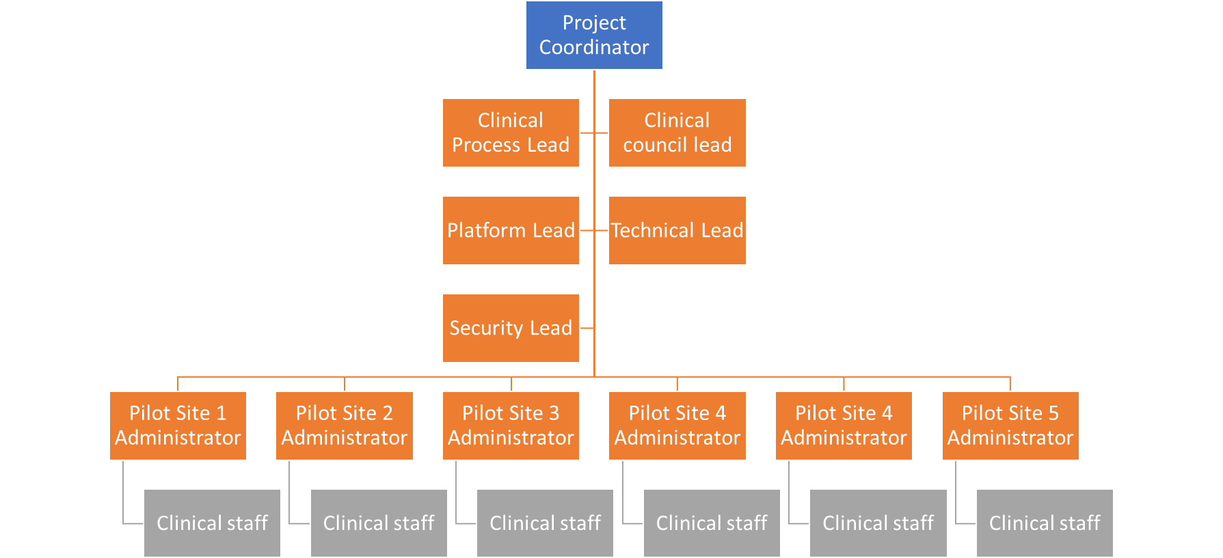

Figure 15: Organization of the SmartConnect Project

## Consortium as a whole

SmartConnect project aims to launch Pilot sites for integrated and personalised care across 5 countries in Europe. In addition, 2 more countries are involved in technology delivery and support for the Digital platform. The Pilot sites are located in the Netherlands, Spain (2 sites), Italy and Greece. The consortium is well balanced across technology companies, healthcare companies, private Cancer clinics, public hospitals, NGO for cancer care at home, and large academic hospitals.

Each of the clinical partners have over 10+ years of Palliative care experience as they actively manage patients in Palliative care programs. Each of the clinical partners also have also demonstrated strong evidence based methods to validate their current Palliative care programs, identification and care delivery.

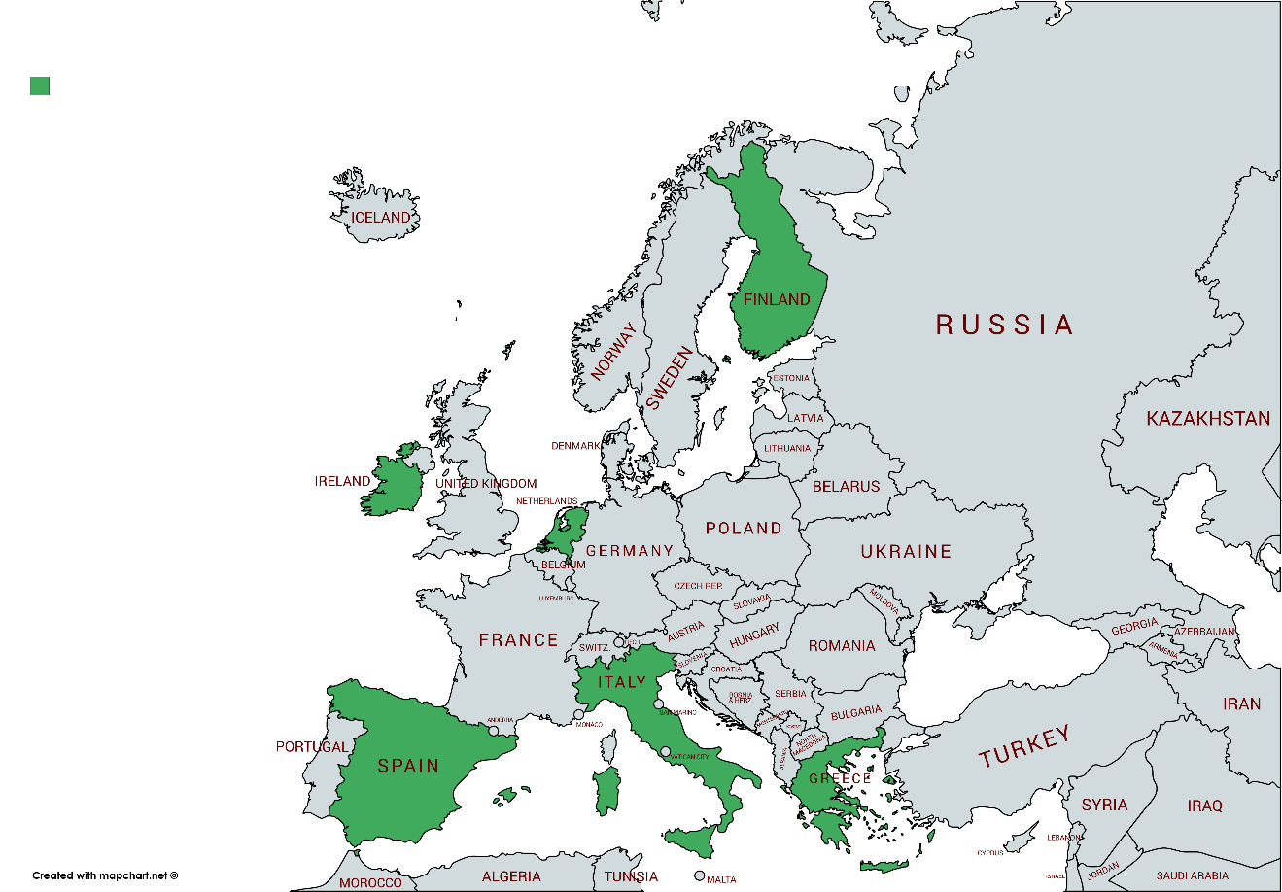

Figure 16: Consortium Partners

|  |  |  |  |  |
| --- | --- | --- | --- | --- |
| **Participant No:** | **Participant** | **Short name** | **Country** | **Role** |
| 1 | ATC (Coordinator) | ATC | Greece | Coordinator |
| 2 | JADS/Technical University of Eindhoven | TUE/JADS | Netherlands | Security and Privacy Workflows and assets |
| 3 | University of Crete Hospital | UOC | Greece | Cancer Center (Pilots Site) |
| 4 | CapsicoHealthCare, Ltd | CAPS | Ireland | Healthcare Platform Company |
| 5 | Tampere University of Technology | TAU | Finland | Workflows assets |
| 6 | Movendos, Ltd | MOV | Finland | Patient engagement tools |
| 7 | Erasmus Medical Center | EMC | Netherlands | Cancer Center (Pilots Site) |
| 8 | Engineering Ingegneria Informatica S.p.a | ENG | Italy |  |
| 9 | AECC | AEC | Spain | Cancer Patient Advocacy |
| 10 | Oncoavanze – Cancer Clinic | ONA | Spain | Cancer Center (Pilots Site) |
| 11 | ANT-Eubiosia – Cancer Care | ANT | Italy | Cancer Care Provider (Pilots Site) |
| 12 | Irish Care Groups | APC | Ireland | Cancer Center (Pilots Site) |
| 13 | Salumedia | SAL | Spain | Mobile rehab tools |
| 14 | SAS Hospital** | SAS | Spain | Cancer Center (Pilots Site) |

## Resources to be committed

* Each Pilot site will allocate several resources for the SmartConnect project
  + Administrator
  + Training specialists
  + Clinical staff responsible for the project
  + Patient education specialists
* Each Pilot site will commit resources per the budget to enable
  + Smooth operations
  + Daily patient review and enrollment

# Bibliography

1. Ferlay, J. et al, Cancer incidence and mortality patterns in Europe: Estimates for 40 countries and 25 major cancers in 2018, European Journal of Cancer, Volume 103, 356 - 387
2. Cancer Statistics, “Eurostat”, 2017, (<http://ec.europa.eu/eurostat/statisticsexplained>).
3. Tit Albreht, Régine Kiasuwa and Marc Van den Bulcke, "European Guide on Quality Improvement in Comprehensive Cancer Control," 2017, Reviewers: European Observatory on Health Systems and Policies.
4. ParkinsonsNet, EU Project: http://www.parkinsonnet.info/about-parkinsonnet
5. Jennifer S et.al., “Early Palliative Care for Patients with Metastatic Non–Small-Cell Lung Cancer," August 19, 2010, N Engl J Med 2010; 363:733-742, DOI: 10.1056/NEJMoa1000678
6. BARBARA HEAD, et. al., “Prognostication in Hospice Care: Can the Palliative Performance Scale Help?, “JOURNAL OF PALLIATIVE MEDICINE, Volume 8, Number 3, 2005
7. NCCN Guidelines for Palliative care
8. European guidelines for Palliative care (Palliative Medicine - The Research Journal of the EAPC)
9. Centeno et.al., "The Palliative Care Challenge: Analysis of Barriers and Opportunities to Integrate Palliative Care in Europe in the View of National Associations," J Palliat Med. 2017 Nov;20(11):1195-1204. doi: 10.1089/jpm.2017.0039. Epub 2017 May 16.
10. Lynch T, et. al., “Barriers to the development of palliative care in Western Europe, “ Palliat Med. 2010 Dec;24(8):812-9. doi: 10.1177/0269216310368578. Epub 2010 May 25.
11. Den Herder-van der Eerden, “How continuity of care is experienced within the context of integrated palliative care: A qualitative study with patients and family caregivers in five European countries,” Palliat Med. 2017 Dec;31(10):946-955. doi: 10.1177/0269216317697898. Epub 2017 Mar 1.
12. Payne S, et. a., “Enhancing integrated palliative care: what models are appropriate? A cross-case analysis,” BMC Palliat Care. 2017 Nov 28;16(1):64. doi: 10.1186/s12904-017-0250-8.
13. DiMattero MR. Variations in Patients' Adherence to Medical Recommendations: A Quantitative Review of 50 Years of Research. Med Care 2004; 42: 200-209.
14. Sullivan S, Kreling DH, Hazlet TK. Noncompliance with medication regimens and subsequent hospitalizations: a literature analysis and cost of hospitalization estimate. J Res Pharmaco Econ, 1990; 12:19-33
15. IOM Report, “To Err is Human: Building a Safer Health System,” Nov 1st, 1999, National Academies Press, Washington DC.
16. Haynes RB, McDonanld H, Garg AX, et al. Interventions for helping patients to follow prescriptions for medications. Cochrane Database Syst Rev, 2002; 4.
17. Smith, R, What clinical information do doctors need? BMJ 1996;313:1062-1068.
18. DiMatteo MR, Giordani PJ, Lepper HS, el al. Patient Adherence and medical treatment outcomes: a metal-analysis. Med Care. 2002; 40:794-811.
19. Reproduced from Christensen AJ. Chapter 3: Determinants of Patient Adherence, in: Patient Adherence to Medical Treatment Regimens, Yale University Press, 2004, p 39.
20. J. Sairamesh, et. al., “Early Warning Methods for Patient Care: Harnessing Insight from Raw Notes,” Proceedings of the Data Mining in Health Informatics Conference, 2008, Washington DC.
21. McLellan A, Arndt I, Metzger D, et al. The effects of psychosocial services in substance abuse treatment. Journal of the American Medical Association (1993). 269 (15), 1953-9.
22. MA Andrade and A Valencia (1998). "Automatic extraction of keywords from scientific text: application to the knowledge domain of protein families". Bioinformatics. 14(7): 600-607.

1. Www.ActiveAge.eu
2. www.mastermind.eu
3. http://pilotsmartcare.eu/home.html
4. https://ec.europa.eu/eip/ageing/action-groups-eip-aha/b3-integrated-care_en
5. Internet of Things (Smart living environments)
6. http://www.casa-europe.eu/
7. http://www.act-programme.eu/
8. www.interreg4c.eu
9. own PALL-C is a Palliative questionnaire used by Erasmus-MC (EMC), one of the partners in SmartConnect
10. Vertical integration is done by a hospital system delivering clinical care by using their internal network
11. Horizontal integration is connecting professionals e.g. pharmacists, GPs, therapists outside of the hospital network
12. <https://www.hyperledger.org/projects/fabric>, <https://nem.io/>
13. <https://blockstack.org/>
14. https://rinkeby.io